CAMPO/LAKE MORENA

COMMUNITY PROTECTION & EVACUATION PLAN

COMMUNITY OVERVIEW
Temporary Update
Updated by Craig Williams W6CAW
Not approved by any government agency

Updated July 31 2013

Edited for Public Distribution on

INDEX

1. Community Overview & Current Conditions
2. Campo/Lake Morena Region
3. Community Stakeholders List and Master Callout Phone Tree
4. Mitigation Strategy & Action Plan
5 Community Protection and Evacuation Plans
5.2 Safety Zones and Fire Breaks
5.3 Shelters and Assembly Areas
5.4 Resident and Resource Map with GPS Information
5.5 Neighborhood Emergency Response Teams and Resources
5.6 Community Alert and Notification Plans
6. Fire Agencies Plans and Resource List
7. Law Enforcement Resources
8. Campo/Lake Morena Animal Rescue
9. Mass Casualty and other Medical Response Plan
9.3 Shelters and Assembly Areas
11. Important Phone Numbers & Contact Information
12. Fire Protection by Community
13. Community Water Resources Locations
16. Logistics Resource List
VEGETATION MANAGEMENT WEBSITES
18.0 Incident and Disaster Center Command System, (ICS & DCCS)
19. The Incident and Disaster Center Command System Forms
20. Communication Resources and Frequency Assignments
14. Terrorism Planning and Response
15. Training and Certification Information
ACRONYMS AND DEFINITIONS

1. Community Overview & Current Conditions

1.1 Key features of the Campo-Lake Morena area include the type of canyons described in the history, but also large flat areas of fuel loads that can result in rapid spread of fire. Winds are common with the dry strong north and east winds (Santa Annas) the most deadly in relation to fire. The usual wind is from the west and south that also can be a problem as they can be strong at times.

1.2 Although the area is not densely populated, there are five areas with fairly dense clusters of housing: Campo, Cameron Corners, Lake Morena, Shockey Truck Trail area and the southern part of Buckman Springs Road. These areas are all highly vulnerable to fires.

1.3 Besides the major water storage at Lake Morena, the area has many small lakes and ponds. This provides the area with a readily available water supply for firefighters, especially helicopters.

1.4 The railroad is a potential hazard because of the types of freight it can haul (i.e., propane tank cars). There have been situations where wheel sparks, overheated brakes, or carbon sparks from the engine exhaust have resulted in brushfires.

1.5 Only two roads, Buckman Springs and La Posta, can be used for north/south traffic to the freeway. Both roads can and have been blocked by natural problems of flooding, snow fall, and/or fire. Vehicle accidents have also closed them.

1.6 This area has not had a severe earthquake since about 1890. However, there are several known faults 50 to 100 miles east of here, such as the San Jacinto, Elsinore and the San Andreas, that could have significant effects in this area.

1.7 Also, there is the new danger posed by possible terrorist events in San Diego. A significant event could cause power outage, disease and a mass influx of people to this area in need of shelter and support.

1.8 The US-Mexico border has historically been a source of many problems. Fires that start in either country, depending on wind conditions, can easily spread to the other.

1.9 The map in Figure 1 shows the general location of some of these potential problem areas and the type of problems considered possible.

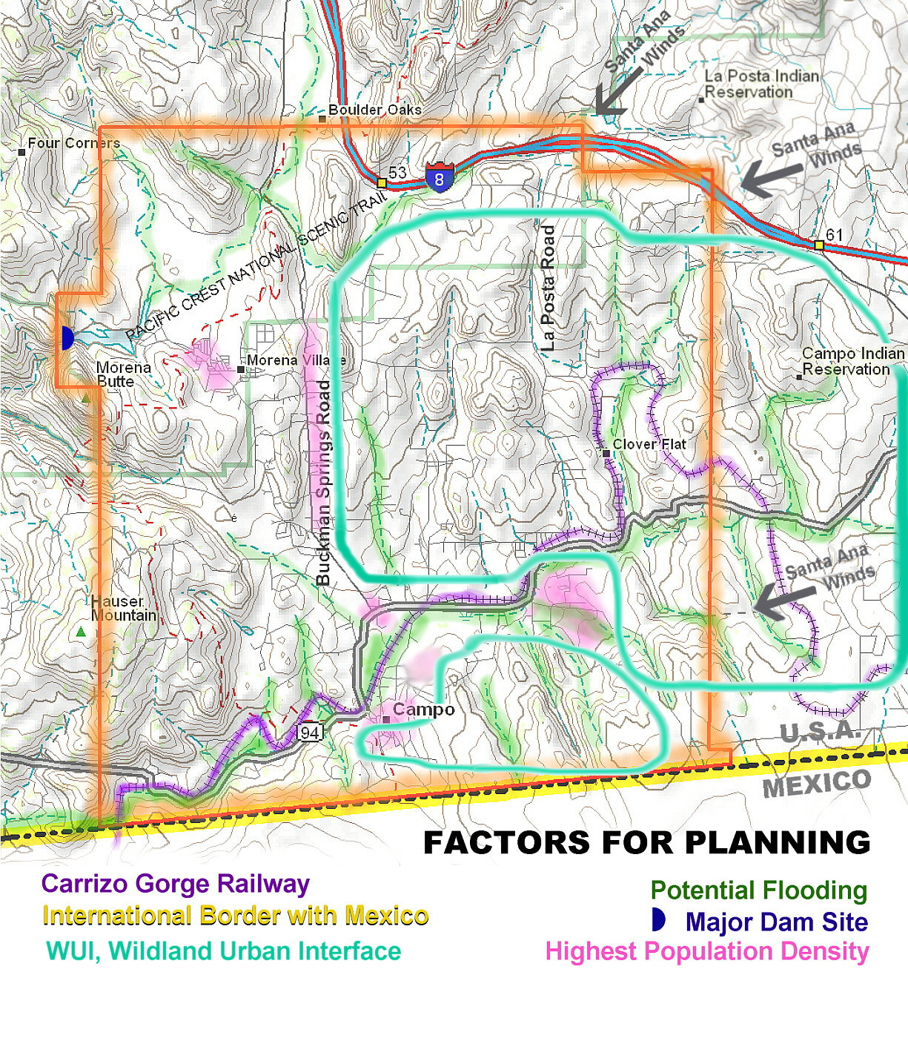

Figure 1

COMMUNITY HISTORY

2. Campo/Lake Morena Region

2.1 The Campo/Lake Morena area covers about 70 square miles. It goes from the Mexican border on the south to Interstate 8 on the north and from the large Campo Indian Reservation on the east to about halfway to Potrero on the west. It conforms to the Campo/Lake Morena Planning Group Area. It has a long history of nature-related emergencies. Fire is the most common problem with a long history of small and large brush fires. Size and extent of the fires is related to wind conditions, humidity, fuel load, and resources available. It is not unusual for a small fire to suddenly expand to a large area. The extent of dirt roads, often narrow and twisting, makes evacuation and assistance difficult.

2.2 Some of the areas that have burned in the past are potential problems now. An example would be Hauser Canyon. It suffered a major 16,000-acre fire in 1943 killing eleven military firefighters, ten Marines and one soldier. There is only one narrow road from the west entrance with a second narrow road from the south that makes any evacuation of residents coupled with the need to bring in fire equipment extremely difficult. A fire in that canyon with a strong East or West wind could result in a blowtorch effect. This canyon has not had a major fire in more than 60 years, so the fuel load is extreme.

2.3 The area has a history of flooding from sudden storms that can bring large amounts of rain in a short period of time. The best example is the sudden downpour in 1891 that dumped 11-1/2 inches of rain in less than 80 minutes (probably more but the rain gauge washed away). The 1916 downpours, known as the Hatfield floods, caused millions of dollars of damage. Heavy rains in the late 1970's and early 1980's resulted in roads and homes covered with water with property damage. The build up of homes in low-lying areas leads to a potential for serious concerns along with animals isolated or drowned (potential for water contamination).

2.4 Extreme snowfalls, while not common, can and do happen in the region. The resulting road closures and power line breaks cause not only isolation of residents but dangerous situations. The need for rescue and shelter for people and animals is critical.

2.5 This area is not urban but we do have some areas where clusters of homes create a near urban environment. In this sense we do have a wildland urban interface (WUI). The map in Figure 2A shows the general areas of high fuel load consisting mostly of high brush generally on the Northeast side of clusters of homes which poses the largest problem when combined with the severe East Winds.

2.6 The map in Figure 2 shows the general location of these local events and what kind of event it was.

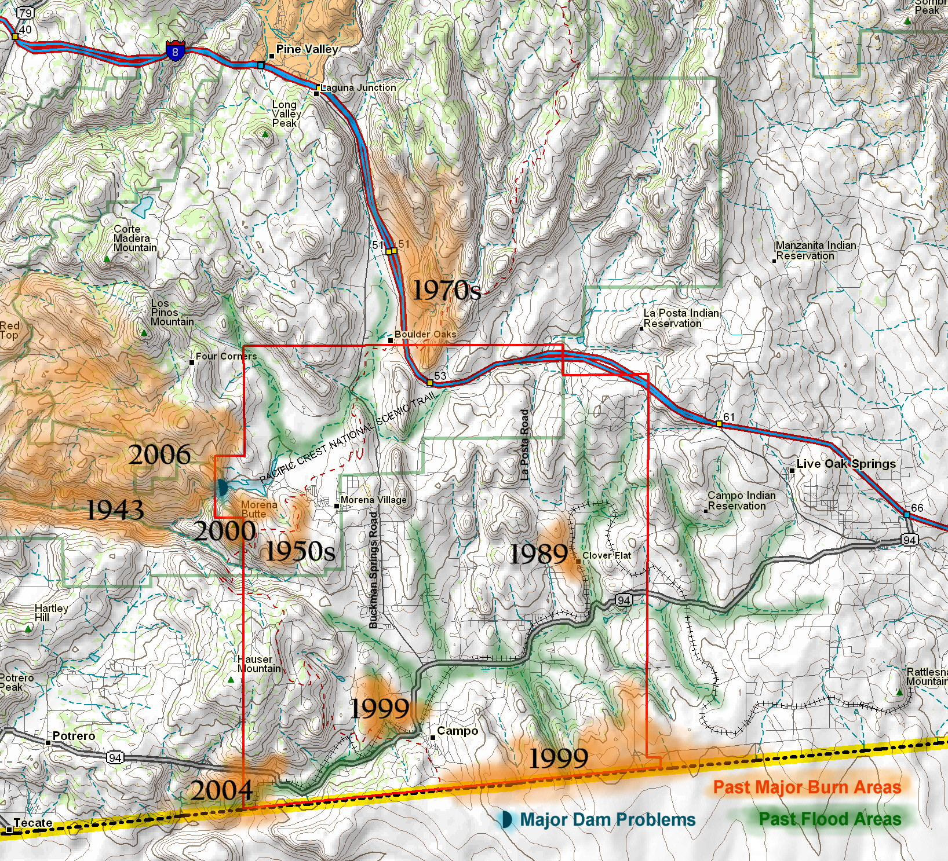

Figure 2

COMMUNITY STAKEHOLDERS
LIST

3. Community Stakeholders List and Master Callout Phone Tree

3.1 The decision to open an Emergency Evacuation Shelter is made by the American Red Cross, San Diego/Imperial Counties Chapter; or Director, San Diego County Office of Emergency Services; or Director of Health & Human Services Agency (HHSA), County of San Diego; or the County’s Chief Administrative Officer (CAO). They will contact the person in charge of the facility(s) they desire to use and get agreement to proceed with the opening of an Emergency Shelter or other similar function. In the event that a group of citizens or a community organization opens a shelter without Red Cross or County HHHS approval, that entity will assume financial responsibility for the shelter. For the Campo/Lake Morena Disaster Preparedness Committee, the CEO of the Mountain Health and Community Services (MHCS) or the designate, will give approval to open the Campo Community Center when some other agency is not operating it and a valid need exist. The person in the top box of the Callout Phone Tree will contact the people immediately below them. This will initiate the Callout process. The people called will then call the next person below them until they have contacted someone who can continue to spread the message throughout the tree. The extent of the callout should be consistent with the severity of the problem and should be coordinated with the local Fire Department, the local Sheriffs Department, the US Border Patrol, the California Highway Patrol or any other agency involve in the activation. Refer to Unit 18.0 for information associated with the Incident Command System (ICS) and the Disaster Center Command System (DCCS) that will be utilized as required depending upon the severity and number of incidents that have occurred.

3.2 The information passed to the people on the Callout Tree should be short, clear and concise. It should inform the person of what the Incident is, where it is, which Emergency Evacuation Shelter will be opened and if their services are needed. If the Red Cross is opening the Shelter, any volunteers that assist them will need to meet their minimum training requirements. If the Shelter is opened by MHCS, the volunteers will need to complete a Volunteer Form and be approved by the MHCS person in charge. If the Campo/Lake Morena Disaster Preparedness Committee works with a different facility and organization, they need to follow the requirements of that organization.

3.3 Another useful list is the “Community Personnel, Phone Numbers & Function” that is organized by Community. It gives the names, telephone numbers and functions of First Responders and key community personnel. This information will be revised periodically as required. All information in this document should be used for public safety and is considered confidential and not to be used for business or personal gain.
Figures 3a and b and the “Community Personnel, Phone Numbers & Function” list and phone trees are not included in this internet version due to confidentiality. However, if you have any questions or need additional information you may call the following people:

Craig Williams W6CAW Campo Fire Communications / RACES
(619) 806-4146 C

MITIGATION STRATEGY

4. Mitigation Strategy & Action Plan
4.1 The County of San Diego has developed an Action Plan with ten specific goals and many supporting actions to help accomplish the goals. Some of the Goals associated with the coastal areas do not apply here. The most significant Goals that do apply to our mountain area are:

Goal 1: Promote disaster resistant future development
Goal 3: Build and support local capacity and commitment to become less vulnerable to hazards.
Goal 4: Enhance hazard mitigation coordination and communication with federal, state, local and tribal governments.
Goal 5: Reduce the possibility of damage and losses … due to dam failure.
Goal 6: Reduce the possibility of damage and losses … due to earthquake.
Goal 8: Reduce the possibility of damage and losses … due to landside.
Goal 9: Reduce the possibility of damage and losses … due to flooding.
Goal 10: Reduce the possibility of damage and losses … due to structural fire/wildfire.

4.2 Of the above Goals, number ten (10) is the most obvious and critical item for our area. The others are important and could under the right conditions be very serious. Our area will be very interested in supporting the County of San Diego with the accomplishment of the established goals. We can do this through the various organizations in the area, with volunteers, with the Campo/Lake Morena Planning Group and through individual participation and training.

COMMUNITY PROTECTION
AND
EVACUATION PLANS

5. Community Protection and Evacuation Plans

5.1 Campo Area Evacuation Routes. Evacuation routes will be selected based upon the emergency situation affecting the Campo area.
Danger from the west: If the danger is to the west of Campo and moving towards the area an easterly evacuation route should be taken. The safest easterly route will be on SR94 toward Boulevard, CA. At the intersection of SR94 and Old Highway 80 evacuees could continue onto Interstate 8 toward El Centro, CA.
Danger from the east: If the danger is to the east of Campo and moving towards the area a westerly evacuation route should be taken. The most direct route to the west is SR94 toward San Diego, CA. It should be noted that this route offers a desirable direction but in the case of flooding it could cause difficulties. An alternate to this route might be County S1 (Buckman Springs Road) to Interstate 8 west toward San Diego, CA.
Danger from the north: If the danger is to the north of Campo and moving towards the area again the evacuation should be either of the two routes described above: SR94 east or west. Also a turn toward Tecate, CA (on SR188 West of Potrero) may be used if the danger requires a southern route. Evacuees would then use the International Border into Mexico as an alternate.
Danger from the south: If the danger is coming from the south and moving toward the area, two routes will move the evacuees to the north. First is County S1 (Buckman Springs Road) and second is La Posta Road. Using the La Posta Rd. escape route requires the additional use of Old Highway 80 east or west, then connecting to Interstate 8 east or west.

5.1.1 Possible emergency situations. Several emergency situations can cause an evacuation in this area. Fire is the most prevalent danger, but flash flooding, earthquakes, or other events may trigger the need for these routes to be used. When contemplating a specific route, the nature of the danger has to be foremost in the mind of the evacuee and the safest routes should be taken. Typically the sheriffs in the area will give directions for an evacuation and instructions as to where to go and what route to follow. The individual should be aware of his circumstances, keep up with the news and take action personally if they or their family seem to be in danger. The following map in Figure 6 shows the local roads and various routes that may be taken if needed.

5.1.2 Local map for the Campo/Lake Morena area.

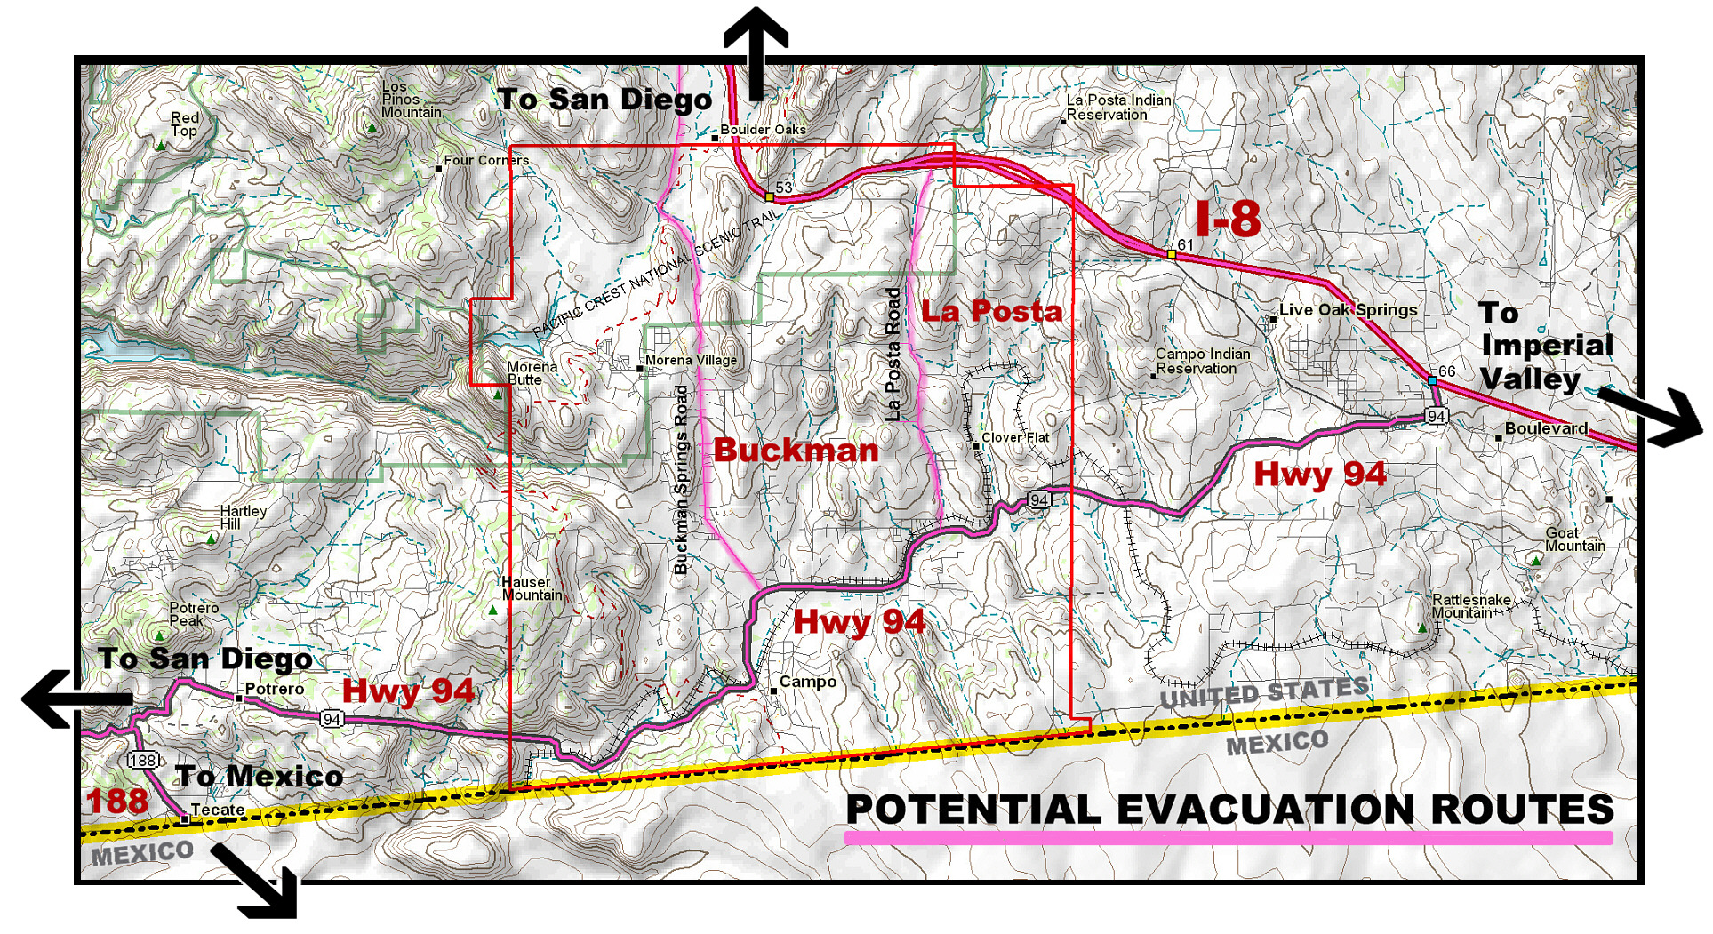

Figure 6

5.2 Safety Zones and Fire Breaks.

5.2.1 In the Campo/Lake Morena area, there are several places where people could assemble for a few hours and be relatively safe from most dangers that might be forcing people to seek safety. It will obviously depend on what the danger is of course. Places with open space, plenty of rooms to park, but not necessarily with water and restroom facilities are described below. About the only large fire breaks in the area are the natural ones created where the grass is still green in the summer such as in the Campo Valley. Permission to use these places should be verified again before directing people to them.

5.2.2 Possible Areas.

- Mtn. Empire High School, East side of Buckman Springs Rd, 2 miles South of Old Highway 80.
  - Parking lot and playground area.

- Campo Community Center, 976 Sheridan Rd., Campo, CA. (619) 478-2384 or 478-5109.
  - Ball field parking lot area.
  - Parking lot area between the Thrift Store and the Community Center
  - Other streets and open areas in and around Campo

- Cameron Corners Area, junction of Buckman Springs Rd. and Highway 94
  - Parking areas in front of the business and nearby.

- Campo Indian Reservation Headquarters, junction of Highway 94 and Church Rd. (619) 478-5400
  - Large parking area and open space.

- Golden Acorn Casino, junction of Church Rd. and Old Highway 80. (619) 478-5400
  - Large parking area and open space.

- Leach-Johnson Ranch, one-quarter mile South of Highway 94 on Dewey Pl. near Cameron Corners. Contact Arvy or Larry Johnson at (619) 478-5566.
  - Large parking area and open space.

- Star Ranch, one mile North of Campo on the West side of Highway 94. Contact Gene Vick at (619) 478-5457.
  - Large parking area and open space.

5.3 Shelters and Assembly Areas

5.3.1 Primary shelters. There are two primary Emergency Evacuation Shelters in the Campo/Lake Morena area. It is also very important to be aware of other potential shelters in the neighboring communities. The following alphabetical list includes community, locations, addresses, contact names, telephone numbers and directions.

5.3.2 Emergency Evacuation Shelter List. (FOUO)

See Appendix J.

5.4 Resident and Resource Map with GPS Information

5.4.1 We have collected information pertaining to citizens whom need special assistance in an emergency, sources of safe drinking water in the area, sources of water for animals, large reservoirs, ranch ponds and motor fuel supplies. These items will be identified and located on a large-scale map or combination of maps along with other data as required. The roads and trails in the area will also be identified so the map will be useful as handouts to give directions to someone needing to find a specific location in the area.

5.4.2 Important items will have Global Positioning System (GPS) coordinates associated with them so that information can be shared with Agencies and individuals as required to locate an item of interest.

5.4.3 The Bureau of Land Management, the San Diego County Sheriffs Department and the US Border Patrol all have mapping systems and utilize the GPS coordinated system to some extent. Our mapping effort will make it easier and faster to coordinate with them if the need arises.

5.4.4 These maps can be used as an Incident Status Map, helping to stay current on the status of an event and provide visual information to the Disaster Center Control System volunteers, the public and the media.

5.4.5 The maps will not be a integral part of this procedure due to the complexity, size and data content. They will however be available at the prime Emergency Evacuation Center for our area. They will also be portable and can move quickly with the other operation support material as required.

5.5 Neighborhood Emergency Response Teams and Resources

5.5.1 There are several neighborhood response teams in the Campo/Lake Morena area. The primary ones are the professional ones in the form of the Sheriff’s, the Fire Departments, the US Border Patrol, the Calif. Highway Patrol and the local ambulance service. These organizations have been discussed throughout this procedure but there are other teams that also help in emergencies.

5.5.2 One of the other key volunteer emergency response teams are the Community Emergency Response Teams (CERTs). These are people whom have had special training in the basic disaster skills, such as fire safety, light search and rescue, team organization, and disaster medical operations. These CERTs can provide valuable assistance to the professional organizations mentioned above and to the public in general. They often play a key role in local emergency training, organizing groups and teaching classes.

5.5.3 To become a CERT member, you will have to take the CERT training from a sponsoring agency like an emergency management agency, fire department or police department. One of the agencies that can provide CERT training is the San Diego Branch of Citizens Corps. See Appendix V in this procedure for CERT and other training that is available and very useful.

5.6 Community Alert and Notification Plans

5.6.1 The San Diego Emergency Alert System (EAS) covers the entire County. Two radio stations, KOGO, AM 600, and KLSD, AM 1360, have been provided with back-up generators and are the primary Emergency Alert radio stations for our community. There is also a small community radio station located in Potrero, KJBQ FM 103.3 that will transmit approved community alert messages. The station cannot currently be received in most places in our area but the owner is attempting to locate an antenna and transmitter on Los Pinos Mountain. If that effort is successful, most of our community will be able to receive that station also.
There are also two important internet web sites that have important information on an emergency situation, they are; http://www.readysandiego.org and www.campofire.org.

5.6.2 The Sheriff’s Communication Division now has the Reverse 911-Callout System, known as SENS, to notify the residents of an evacuation. This system will automatically call all residences in an area and play a recorded message.

5.6.3 The following is the general sequence of events during an emergency that may involve an evacuation.

- During a critical incident where residents will be evacuated the first responders on scene will be Deputy Sheriff’s who are either working or called out.
- They will meet with Fire Department personnel who will advise them of the critical areas that need to be evacuated. Once these areas are identified, the deputies are responsible for the evacuation.
- The deputies will notify their sergeant who will determine what resources will be needed. If additional deputies are needed he will make a request for the manpower needed to get the evacuation done.
- He will have all deputies in the immediate area called out and then go to the surrounding areas. This would include all major stations if necessary. There would be no problem getting the necessary manpower.
- A command post will have been established which deputies report to. They will be given their assignments.
- Once the order to evacuate is given, the deputies will start the evacuation process. They will go to the designated area and, with the use of their car loud speaker, make the announcement to evacuate. At the same time deputies will be going house-to-house advising people to leave their residence and telling them of a safe route to take.
- If ASTREA (helicopter) is available they will also make announcements over their loudspeaker to evacuate.
- The Sheriff’s Dept. may get help from the California Highway Patrol and or the US Border Patrol if needed.

Note: Law Enforcement Officers cannot force a person to evacuate, they can only advise the person to leave his residence, it’s up to the individual to make the choice. In an emergency where time is critical and a person refuses to evacuate, he is on his own. We will not risk lives to help somebody who puts himself or herself in harms way when other people need the services. The only exception to the rule is if there are children involved. A parent cannot put his children at risk. If children are involved in a forced evacuation and the parent refuses to evacuate and keep the children with him, he can be arrested and the children removed to a safe place.

FIRE AGENCIES RESPONSE PLANS AND RESOURCES

6. Fire Agencies Plans and Resource List

6.1 Fire is our most obvious danger in the Campo/Lake Morena area. We are fortunate in having good service from a variety or organizations. Each organization has its own plans and areas of responsibility. These organizations are constantly improving their capability to complete their assigned tasks and they work constantly on coordination between agencies. This list is simply to provide identification, contact information and the general duties of the agencies.

6.2 General Duties
    - Acts as Incident Commander
    - Performs as the “single ordering point” of additional resources.
    - Notifies Sheriff’s Communications Center of the Annex D or P activation through their local Dispatch Center.
    - Utilizes ICS to manage scene operations and resources via branches such as the Multi-Casualty Branch.
    - Provides fire fighting.
    - Provides extrication.
    - Provides rescue.
    - Provides initial triage and medical support.
    - Maintains communications with their Communications Center.
    - Coordinates air operations at the scene.
    - Determines need for treatment teams on scene.
    - Determines the need for all additional resources and orders them as necessary.

6.3 Boulevard Fire Department (47). 39223 Hwy. 94, Boulevard, CA (619) 766-4633 Facility has emergency generator power.

6.4 Cal Fire-California Department of Forestry. Campo Station (40), 31577 Highway 94, Campo, CA 91906. (619) 478-5516, FAX 478-2439. Headquarters, Monte Vista Station, 2249 Jamacha Road, El Cajon, CA 92019 (619) 590-3100, FAX (619) 590-3106 Facility has emergency generator power.

  - Campo Fire and Rescue (46). 437 Jeb Stuart Rd., Campo, CA (619) 478-5310, Fax (619) 478-5836. campofire@yahoo.com. Communications/EOC Craig Williams W6CAW. (619) 806-4146 cell, County pager number (858) 492-9825 ext. 2068. Facility has emergency generator power. www.campofire.org .
    - Emergency Operations Center (EOC)
    - HF/144/220/440Mhz Amateur Band & RACES Transceivers
    - “Red Dot” and FRS Transceivers for community communications
    - Public Service VHF Portable Radio Cache
    - Laptop PC / Printer for reports, mapping and internet
    - Emergency email address campofire@yahoo.com
    - 800 Mhz Fire and OES public service radios
    - Emergency powered by 12V, gel cell batteries

6.6 Campo Indian Reservation Fire Dept (65). 36210 Church Road,
Campo, CA 91906-2713 (619) 478-2371

6.7 Cal Fire-California Department of Forestry, Dulzura Fire Station (30). 17304 Highway 94, Dulzura CA 91917(619) 468-3431, FAX (619) 468-3276

6.8 Jacumba Fire Dept. (43) Rural Fire. 1255 Jacumba Street., Jacumba, CA (619) 766-4535, FAX (619) 766-0887

6.9 Lake Morena Fire Department (42) Rural Fire. 29690 Oak Drive, Campo CA 91906. (619) 478-9502, FAX (619) 478-5960 Facility has emergency generator power.

6.10 Cal Fire-California Department of Forestry, Potrero Fire Station (31). 25130 Highway 94, Potrero CA 91963 (619) 478-5544, FAX (619) 478-2452

6.11 Cal Fire-California Department of Forestry, White Star Fire Station (41). 1684 Tierra Del Sol Road, Boulevard CA 91905. (619) 766-4533 FAX (619) 766-4215

6.12 U.S. Forest Service. 3348 Alpine Blvd., Alpine, CA (619) 445-6235.
Cameron Station (619) 473-8784. Cottonwood Station (619) 473-9835

LAW ENFORCEMENT RESOURCES

7. Law Enforcement Resources

7.1 The Campo/Lake Morena area is served primarily by the San Diego County Sheriffs Department. It has offices nearby in Campo, Pine Valley, Boulevard and Potrero. The California Highway Patrol also supports us for anything dealing with the highway system. We also have the US Border Patrol with local major stations at Campo and Boulevard. All three of these organization work well together and give very good coverage no matter what the problem is. The following list gives quick contact information and a summary of their responsibility.

7.2 Campo Sheriff’s (Department) Substation. 378 Sheridan Rd, Campo, CA 91906 (619) 478-5378, FAX (619) 478-9076; dispatch (858) 565-5200. (619) 478-4662. Pine Valley substation (619) 478-5873
  - Acts as LE incident commander during law enforcement emergencies.
  - Two communication vehicles located in San Diego.
  - Provides crowd and traffic control.
  - Provides tactical communication.
  - Establishes and maintains ingress and egress routes for emergency vehicles.
  - Provides perimeter control.
  - Provides security at the scene.
  - Provide community evacuation warnings.

7.3 California Highway Patrol California Highway Patrol. 1722 E. Main, El Cajon, CA (619) 401-2000; dispatch (858) 637-3800. www.chp.ca.gov .

7.4 Border Patrol.
Campo Station ( East of Buckman Springs Road ) 32355 Old Highway 80 Pine Valley, California 91962. Phone: (619) 938-8700 Fax: (619) 478-9793
El Cajon Station ( West of Buckman Springs Road ) 3 Forrest Gate Rd / P.O. Box 68, Campo, CA 91906. (619) 938-8700
Boulevard Station 2463 Ribbonwood Rd. Boulevard, CA 91905 Phone: (619) 766-3000 Fax: (619) 766-9060
El Cajon office, (619) 258-4500
Brown Field office (619) 661-3148
Border Patrol dispatch number: (800) 808-8727

ANIMAL SERVICES RESPONSE PLANS

8. Campo/Lake Morena Animal Rescue

8.1 Animal rescue for this area is primarily coordinated through the San Diego Humane Society/Animal Rescue organization. The Sheriff or Fire Department Incident Commanders typically initiates activation. Since our area is fairly remote, there are two plans of action for this area. The first works directly with the San Diego Humane Society and the second works independently but still using their methods and practices. The Camp Lockett Event and Equestrian Facility, is our primary local shelter/facility for animals.

8.2 On-site Plans.
The managers have a set of plans on site for operating the facility and for relocating to another facility if the need arises. Their plan is very similar to the Disaster Center Control System (DCCS) in Unit 18 that will be used to establish an Emergency Evacuation Shelter. Figure 6 below shows the Organization Chart for the Camp Lockett Event and Equestrian Facility Animal Rescue operation. They will use some of the forms in Unit 19 but due to their unique function they will have additional forms that they will maintain. Their plans are outlined below. Before participating in either Plan One or Plan Two, be sure to take care of your personal and family security first and then wear suitable clothing for working outside in the weather with animals.

8.3 Plan One Description.
Animal Rescue is called out and will be doing animal rescue in the Mtn. Empire area. This is done automatically through Communications with Fire/Sheriff/Animal/Humane Society.

8.4 Plan Two Description.
Animal Rescue is unable to respond to our area and we are on our own to rescue animals and bring them to the Camp Lockett Event and Equestrian Facility The Disaster Commander – who is the first person to arrive at the ranch – will give directions for rescues. Plan on three people per vehicle that will go, as well as a scout vehicle. Take a walkie-talkie, the proper forms and a pen – given to you at the command center, and take enough lead ropes and halters for the number of horses you can transport. Remain calm and drive safely. DO NOT take any unnecessary risks. Once to the area to pick-up animals, follow the directions of law enforcement. Follow all safety procedures for removing animals and return to the ranch for unloading.

The DISASTER COMMANDER will give further instructions once you are at the Camp Lockett Event and Equestrian Facility

In the event that we need to move our own animals or those of neighbors immediately and we cannot go to the Camp Lockett Event and Equestrian Facility, we have a phone tree so we can call the people who will help us. It is included in Unit 3. FIRST CALL is always to Animal Rescue (619-299-0871). Included in Unit 5 are also directions for evacuating to the west or to the east – both using Hwy. 8. This evacuation plan is also in effect in the event that we need to evacuate from the Flying “A”.

8.5 Important Telephone Numbers Associated with the Camp Lockett Event and Equestrian Facility.
San Diego Humane Society 619-299-0871
Freedom Ranch 619-478-5696
Imperial Co. Fairgrounds 760-355-1181 W 760-427-3230 C

(Again – additional contacts have been removed for confidentiality.)

8.6 Alternate Rescue Locations
There is a backup list of locations that could be available for temporary relocation of animals if they are needed.

CAMPO/LAKE MORENA ANIMAL RESCUE
DISASTER CENTER COMMAND SYSTEM (DCCS)
ANIMAL RESCUE DISASTER
CENTER COMMANDER
SAN DIEGO HUMANE SOCIETY
& LIASION CHIEF
PUBLIC INFORMATION
CHIEF
SAFETY
CHIEF
LOGISTICS CHIEF
INITIAL INTAKE AND
ANIMAL CONTROL
MATERIAL
SUPPLY
TRANSPORTATION
PERSONNEL &
ANIMAL FACILITIES

INCIDENT
COMMANDER(S)

OPERATIONS CHIEF

MEDICAL
COORDINATOR

SECURITY

Figure 6
PLANNING

MASS CASUALTY AND OTHER MEDICAL RESPONSE PLANS

9. Mass Casualty and other Medical Response Plan

9.1 Purpose. Establish procedures to augment medical care resources to accommodate a large number of patients during a disaster or public health crisis in the Mountain Empire Area.

9.2 Objectives. To increase patient volume (surge capacity) and obtain medical resources required to deliver health care under situations which exceed normal capacity including potential available space in which patients may be triaged, managed, vaccinated, decontaminated, or simply located; available personnel of all types; necessary medications, supplies and equipment; and even the legal capacity to exceed authorized care capacity. Normal capacity could be exceeded during any type of emergency for reasons that include the following:
- Convergence of ill or injured resulting from disasters.
- Random spikes in numbers of presenting patients.
- A combination of any of the above.

9.3 Procedure

A. Activation of mass casualty/surge capacity plan. The Executive Director, Medical Director, or Clinical Manager of Mountain Health and Community Services will activate the clinic’s procedures for increasing surge capacity when (1) civil authorities declare a bioterrorist emergency or other disaster that affects the community or (2) clinic utilization or anticipated utilization substantially exceeds clinic day-to-day capacity with or without the occurrence of a disaster.

B. Identify communication linkages.
1. Establish a communication link with Council of Community Clinic’s Emergency Preparedness Coordinator (EPC) by telephone or other method. (619) 542-4345
2. Periodically report clinic status, numbers of ill/injured, types of presenting conditions and resource needs and other information requested by the EPC.
3. Establish a communication link with the Incident Command System (ICS) and the Disaster Center Command System (DCCS), which may be providing an Emergency Evacuation Shelter.

C. Identify, prepare and utilize non-clinic space.

The follow spaces have been identified as temporary treatment rooms, triage areas, patient holding areas or storage area.
- Campo Community Center: Utilized as the Emergency Operations Center. A section of the Community Center may be reserved for triage in which the following facilities will be utilized after initial triage.
- Mountain Empire Family Medicine:
  - Parking lot; Triage and basic medical needs
  - Clinic: Patients requiring immediate medical attention with higher acuity.
  - Administration building: Patients requiring extended medical attention after stabilization. Beds/cots can be used in this area.
- Little League Field: Utilization of tents to assist with overflow from the above. This may also include a temporary morgue if necessary.
- Family Resource Center: Food and water distribution

D. Identification of pharmaceuticals, medical supplies, and medical equipment. MHCS has included in their strategic planning to increase the amount of supplies and equipment for stand-alone capability. This will primarily include equipment and supplies based on availability of funding. It will not include medications due to shelf life and environmental issues. MHCS currently has limited medication supplies on hand at all times which may be utilized in the event of a disaster. Supplies and equipment will be stored on site and will be accessible by MHCS staff in the event of an emergency.

E. Recall and assignment of personnel.
- Mountain Health will work in conjunction with the county and the Council of Community Clinic’s EPC to recruit medical personnel into the above mentioned areas.
- The Human Resources Director at Mountain Health and Community Services shall maintain a current list of it’s employees including their addresses and telephone numbers and will implement call back procedures according to specific plans.
- If the incident occurs during clinic operational hours, the clinic will initially rely on its existing staff for response to the emergency.

F. Setup triage/first aid area.
- The clinic Medical Director or Clinical Manager will establish a site for triage and first aid under the direction of a physician or registered nurse. Triage decisions will be based on the patient condition, clinic status, and availability of staff and supplies. Once patients have been triaged and tagged, they will be directed to a patient treatment area or patient waiting area.
- Medical personnel will report status to facilities with which clinic has patient referral reciprocity or to which patients may be referred. Some patients received in the triage area may have to be transferred to another facility for definitive medical care because the clinic may not be adequately equipped to treat some types of casualties. Every effort should be made to treat/stabilize patients prior to transportations.
- Transportation arrangements are made for patients requiring higher levels of care as rapidly as possible through 9-1-1.

G. Increase security. The purpose of security will be to ensure unimpeded patient care, staff safety, and continued operations. If the clinic management has determined that security augmentation is necessary the following security measures are implemented:
- Security will be provided initially by existing security services or by personnel under the direction of the Security Officer. Existing security may be augmented by contract security personnel, law enforcement, clinic staff or, if necessary, by volunteers.
- Checkpoints at building and parking lot entrances will be established as needed to control traffic flow and ensure unimpeded patient care, staff safety, and continued operations.
- Supervisors will ensure that all clinic staff wears their ID badges at all times. Security will issue temporary badges if needed.
- Security staff will use yellow tape and a bullhorn to assist in crowd control, if needed.
- The Security Officer will ensure that the clinic site is safe and remains secured following an evacuation.

H. References
California Clinic Emergency Preparedness Project. (2004). Emergency Operations Plan Template.
Joint Commission on Accreditation of Healthcare Organizations. (2003). Health Care at the Crossroads: Strategies for Creating and Sustaining Community-wide Emergency Preparedness Systems.
Borrego Medical Center. (1997). Clinic Disaster Plan.
SHELTERS AND EMERGENCY SERVICES RESPONSE PLANS

9.3 Shelters and Assembly Areas

9.3.1 Primary shelters. There are two primary Emergency Evacuation Shelters in the Campo/Lake Morena area. It is also very important to be aware of other potential shelters in the neighboring communities. The following alphabetical list includes community, locations, addresses, contact names, telephone numbers and directions.

9.3.2 Emergency Evacuation Shelter List.

Alpine: Alpine Community Center, 1830 Alpine Blvd., Alpine, CA (619) 445-7330.
Coming from El Cajon: Take I-8 East toward El Centro. Take the Tavern Road exit toward ALPINE. Turn right onto Tavern Rd. Turn left onto Alpine Blvd. Alpine Community Center is on the left.
Coming from Campo: Turn right onto Forrest Gate Rd. Turn right onto Highway 94. Turn left onto Buckman Springs Rd. Merge onto I-8 W via the ramp- on the left. Take the Tavern Rd. exit (number 30). Turn left onto Tavern Rd. Turn left onto Alpine Blvd. Alpine Community Bldg. is on the left.

Boulevard: Boulevard Community Center, 39919 Highway 94, Boulevard, CA (619) 766-4633.
Coming from San Diego: Take I-8 east to the Ribbonwood exit, go south 1/2 mile to the corner of old Highway 80 and Ribbonwood Road. The center is on the left, connected to the Boulevard Fire Dept and Sheriff substation.
Coming from Campo: On Highway 94, go east to old Highway 80 to Ribbonwood Road, go left and the center is on the right.

Campo: Mountain Empire Community Center, 976 Sheridan Road, Campo, CA (619) 478-2384.
Coming from El Cajon: Take Hwy 8 - east until Buckman Springs Road (also known as County Road S-1). Take off ramp and continue south until you get to the end of the road (about 8 miles). Turn right at stop sign (you are now are on Hwy 94 westbound). Continue until you cross the railroad tracks and turn left at first intersection (Forrest Gate Road). Turn left on Forrest Gate Road (directly across from the Campo Trading Post). Go past the East County Lumber and turn left at first intersection (Border Patrol Station at that intersection). Continue on that street until you get to Sheridan Road (end of road). Turn left. Community Center is about a half block on your left, right across from Sheriff's Office.
Coming from Highway 94: From Potrero go east on Hwy 94. Turn right on Forrest Gate Road (directly across from the Campo Trading Post). Go past the East County Lumber and turn left at first intersection (Border Patrol Station at that intersection). Continue on that street until you get to Sheridan Road (end of road). Turn left. Community Center is about a half block on your left, right across from Sheriff's Office.

Descanso: Descanso Elementary, 24842 Viejas Blvd., Descanso, CA (619) 445-2126; Town Hall, Descanso, CA (619) 445-9505; Our Lady of Light Church, Descanso, CA
Coming from El Cajon: Take Interstate 8 heading east then take the Highway 79 exit from I-8 (Exit 40). Go north on Hwy 79 toward Julian, to Riverside Drive (Descanso Junction). Turn left (northwest) on Riverside Drive, following the sign to Descanso. The school is about 2 miles farther up Riverside from Camp Oliver (turns into Viejas Blvd past Perkins Store).
Coming from Campo: Take Highway 94 East to Buckman Springs Rd. Turn left on Buckman Springs and get on Interstate 8 going west. Then take the Hwy 79 exit from I-8 (Exit 40). Go north on Hwy 79 toward Julian, to Riverside Drive (Descanso Junction). Turn left (northwest) on Riverside Drive, following the sign to Descanso. The school is about 2 miles farther up Riverside from Camp Oliver (turns into Viejas Blvd past Perkins Store).

Descanso: Camp Oliver, 8761 Riverside Drive, Descanso, CA (619) 445-5945.
Coming from El Cajon: Take Interstate 8 heading east then take the Highway 79 exit from I-8 (Exit 40).Go north on Highway 79 toward Julian, to Riverside Drive (Descanso Junction). Turn left (northwest) on Riverside Drive, following the sign to Descanso. Go about 0.25 miles to 8761 Riverside Drive. It’s on the right hand side of the road.
Coming from Campo: Take Highway 94 East to Buckman Springs Rd. and get on Interstate 8 going west. Then take the Hwy 79 exit from I-8 (Exit 40). Go north on Highway 79 toward Julian, to Riverside Drive (Descanso Junction). Turn left (northwest) on Riverside Drive, following the sign to Descanso. Go about 0.25 miles to 8761 Riverside Drive. It’s on the right hand side of the road.

Dulzura: Dulzura Community Building, 1136 Community Building Rd., Dulzura, CA (619) 468-3795.
Coming from El Cajon: Go Hwy 94 heading east. You will go through Jamul to Dulzura. You will pass the Dulzura Post Office and the Dulzura Café. Keep going until you get to Community Building Road and turn right. Follow it to the end. The Community Building is on the right side.
Coming from Campo: Go Hwy 94 heading west. You will go through Campo, Potrero, and Barrett Junction. You will pass the Barrett Café on your right side. Keep going until you come to Community Building Road. Turn left onto Community Building Road. Follow it to the end and the Community Building will be on your right side.

Jacumba: Highland Senior Citizens Center, south side of Old Highway 80 & Carrizo Ave., Jacumba, CA (619) 766-4505. Also Smith Youth Center, corner of Old Highway 80 & Heber, Jacumba, CA.
Coming from El Cajon: Take Interstate 8 East to the Boulevard exit. Turn right and go to the stop sign. Turn left on Old Hwy 80. Head east to Jacumba. The Smith House is on the left (north) at the corner of Heber and Highway 80. The Senior Building is the last building on the right as you leave Jacumba (the last cross street across from the Highland Senior Center is Campo St.).
Coming from Campo: Take Highway 94 East until it runs into Old Highway 80 in Boulevard. Then continue on Highway 80 to Jacumba. The Smith House is on the left (north) at the corner of Heber and Highway 80. The Senior Building is the last building on the right as you leave Jacumba (the last cross street across from the Highland Senior Center is Campo St.).

Jamul: Jamul Primary School, 14567 Lyons Valley Road, Jamul, CA 91935. (619) 669-7800.
Coming from El Cajon: Take Highway 94 heading east. Turn left on Lyons Valley Road. Turn right at the 3-way stop and the primary school is the second school on the right.
Coming from Campo: Take Highway 94 west. Turn right on to Lyons Valley Road. Turn right at the 3-way stop and the Primary school is the second school on the right.

Jamul: Indian Hills Camp, 15763 Lyons Valley Road, Jamul, CA 91935. (619) 669-6498
Coming from El Cajon: Take Highway 94 east. Turn left on Lyons Valley Road. Go through the 3-way stop and that puts you on Skyline Truck Trail. Follow Skyline Truck Trail until you hit Lawson Valley Road. Turn right onto Lawson Valley Road. Turn left onto Lyon’s Valley Road. Indian Hills Camp is on the right side.
Coming from Campo: Take Highway 94 west to Lyons Valley Road. Turn right on Lyons Valley Road. Go through the 3-way stop and that puts you on Skyline Truck Trail. Follow Skyline Truck Trail until you hit Lawson Valley Road. Turn right onto Lawson Valley Road. Turn left onto Lyons Valley Road. Indian Hills Camp is on the right side.

Lake Morena: Lake Morena Pavilion (County Park), 2550 Lake Morena Dr., Campo, CA (619) 579-4101
Coming from El Cajon: Take I-8 East toward El Centro. Take the Buckman Springs exit. Continue south approximately 6 miles. Turn right onto Oak Drive. Continue to the 4-way stop. Turn right onto Lake Morena Drive. Continue to John Lyons County Park. The pavilion is within the park.
Coming from Campo: Take Buckman Springs Road (S-1) north to Lake Morena Drive. Turn left. Continue approximately 3 miles to the 4-way stop. Continue on Lake Morena Drive to John Lyons County Park. The pavilion is within the park..

Potrero: Kiwanis Community Building, 25771 Potrero Valley Road, Potrero, CA (619) 478-2110.
Coming from El Cajon: Take Hwy 94 heading east. You will go through Jamul, Dulzura, and Barrett Junction. You will pass the Hwy 188 turn off. Keep going until you get to Potrero Valley Road and turn left. Take it until you see the Kiwanis Community Building on your right side.
Coming from Campo: Take Hwy 94 heading west. You will go through Campo all the way to Potrero. You will pass the Potrero Café and store on your left and the Potrero Post Office on your right. You will turn right on Potrero Valley Road. Follow it until you see the Kiwanis Community Building on your right.

Potrero: Potrero Community Church, 26409 Highway 94, Potrero, CA (619) 478-2110.
Coming from El Cajon: Take Hwy 94 heading east. You will go through Jamul, Dulzura, and Barrett Junction. You will pass the Hwy 188 turn off. You will pass the Potrero Café and store on your right. Keep going until you see the Potrero Community Church on your right side.
Coming from Campo: Take Hwy 94 heading west. You will go through Campo all the way to Potrero. The Potrero Community Church will be on the left side. If you’ve gotten to the Potrero Café and store you’ve gone too far.

CONTACT INFORMATION

Important Phone Numbers & Contact Information

11.1 Campo, Lake Morena and Back Country Emergency Contact Numbers

American Medical Response (AMR). Campo office (619 ) 478-9459.

American Red Cross. 3950 Calle Fortunada, San Diego CA 92123, (858) 309-1200

Animal Control. Hotline (619) 299-0871

Barrett Feed and Supply (619) 468-3756

Campo Community Center. 976 Sheridan Road, Campo, CA 91906 (619) 478-2384 or 478-5109. Evacuation center. Community gathering point. Disaster assistance assembly point.

Campo Elementary School. 1654 Buckman Springs Rd, Campo, CA 91906 (619) 478-5583

Emergency Public Communications. KOGO Radio Station. Public Information and contacts. 600KHz AM, (858) 560-6671 (News Room).

Freedom Ranch. 478-5696

Humane Society (Animals). Hotline (619 ) 299-0871

Lake Morena Community Church. 29765 Oak Dr Lake Morena 619-478-5917

La Posta EPA. (619) 478-2399

Mercy Air. (800) 222-3456

Mountain Health & Community Service. 31115 Hwy 94 (on Forrest Gate Road), Campo, CA 91906 (619) 445-6200, x160, (619) 972-3843 C, Fax 478-2267.

Mtn. Empire Jr/Sr High School. 3305 Buckman Springs Rd., Pine Valley, CA (619) 473-8601

Navy SEAL Training Site, West of La Posta Rd. and Camp Morena N. of Lake Morena;

RACES (Radio Amateur Civilian Emergency Services). Craig Williams (619) 478-2769 or (619) 806-4146 cell, W6CAW

Rancho del Campo, 957 Forrest Gate Rd., Campo, CA Duty Supervisor. (619) 401-3500.

SDG&E. Old Highway 80 Office. (619) 473-8094 or 260-5748

Salvation Army. (619) 446-0262 Fax (619) 231-6001

2 – 1 – 1 San Diego. A telephone number with local information about health, community and disaster services and related organizations. Just dial 211 on landline phones or use (858) 300-1211 on any cell phone.

11.2 Governmental Agencies Emergency Contact Numbers

Bureau of Land Management (fire prevention). SCA (208) 860-7825

Federal Emergency Management Agency (FEMA). (858) 565-3490. Satellite Disaster Field Office San Diego 9750 Distribution Ave., San Diego, CA 92121. www.fema.org.

Office of Emergency Services (OES). Web site with current status of an emergency with a map, www.sdcountyemergency.com .

Public Health Department. (619) 515-4255 W

US Forest Service. Cameron Station, Buckman Springs Road (619) 473-8784

11.3 Hospitals

Alvarado Hospital 6655 Alvarado Rd, San Diego, CA (619) 287-3270

Grossmont, 5555 Grossmont Center Dr., La Mesa, CA 91942. (619) 465-0711

Kaiser Permanente, 4647 Zion Ave., San Diego, CA 92120. (619) 528-5151

Scripps Chula Vista Medical Center, 435 H. Street, Chula Vista. (619) 691-7000

Scripps Mercy, 4077 5th Ave., San Diego, CA 92103. (619) 294-8111

Sharp Chula Vista Medical Center, 751 Medical Center Court, Chula Vista, CA
(619) 482-5800

UCSD Medical Center, 200 W. Arbor Dr., San Diego, CA 92103. (619) 543-6222

11.4 Animal Rescue

San Diego Humane Society. (619) 299-0871

Southern California Foundation Quarter Horse Club, Tiffani Kjeldergaard, vice president.

11.5 Mountain Empire Organizations

Campo/Lake Morena Planning Group

Council of Community Clinics

Descanso Emergency Preparedness Group.

Dulzura Community Development Committee.

11.6 County, State and Federal Representative Contact List

San Diego County Board of Supervisors 2nd District: Dianne Jacob, 1600 Pacific Highway, Room 335, San Diego, CA 92101 (619) 531-5522 or (800) 852-7322

United States Senate: Barbara Boxer, San Diego office, 600 B St., Suite 2240, San Diego, CA 92101, (619) 239-3884, FAX (619) 239-5719

United States Senate: Dianne Feinstein, San Diego office, 750 B St., Suite 1030, San Diego, CA 92101, (619) 231-9712, Yelena Feldman.

WATER SYSTEMS

13. Community Water Resources Locations

13.1 There are several significant Water Resources in the area that can be used for a variety of purposes. The attached Map shows their general location and Appendix P, Unit 16, gives additional information on these resources.

13.2 We have a few Ponds, Reservoirs and Lakes in the area large enough for fire-fighting helicopters to remove water from to drop on nearby fires. The attached map shows their general location. The largest source is Lake Morena.

13.3 There are also three large water storage tanks in the Campo area. Both belong to the County of San Diego and each contains about ½ million gallons of water. The San Diego County local system management personnel can authorize the use of the water.

13.4 There are many 5 to 10K gallon fire storage tanks located throughout the area that contain potable water. The ones noted on the attached map are the ones that also have emergency generators available to refill the tanks as the supply is depleted. The permission of the owner should be obtained before using these by anyone except by the Fire Departments.

13.5 The Carrizo Gorge Railroad has a large water filled tank car, estimated at 20,000 gallons, which can be moved by the train along the track throughout our area. It has been used in the past to supply water to fire crews in the vicinity of the railroad.

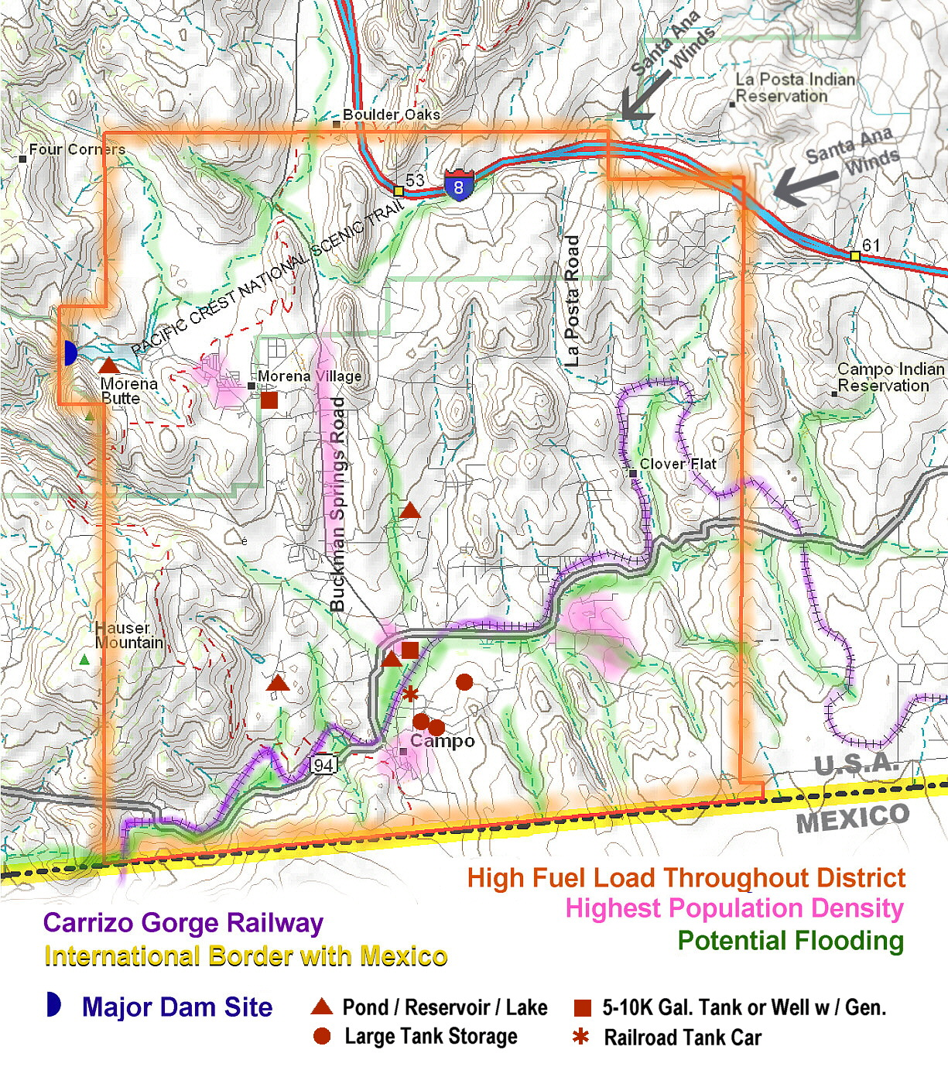

LOGISTICS

16. Logistics Resource List

A resource list pertaining primarily to the Campo/Lake Morena area but including information and resources well outside of our area has been compiled and the agencies and the disaster committee has that list. The operation of an Emergency Evacuation Shelter and the handling of problems associated with various Incidents in and out of our area can utilize these resources if necessary. Specific categories of resources are such as Fire (6.0) and Law Enforcement (7.0) are covered in separate sections of this procedure. This status and existence of items in this list is likely to change over time so it is very important that this procedure and this list be updated at least once a year.

A resource matrix can be downloaded from www.campofire.org Click on the “Disasters” link.

VEGETATION MANAGEMENT
WEBSITES

Topic | Description | Where to get information
A.  Associations, Fire  National Fire Protection Association  National Weather Service  US Fire Administrator  US Geological Survey  Fire Alliance, California  California Fire Safe Council  Fire Wise  Local Agencies:  The Burn Institute  Calif. Dept. of Forestry & Fire Protection (CDF)  Fire Safe Council of San Diego County  Forest Service (USFS)/ Dept of Ag  Animal Control, County  Animal Rescue  Fire & Resource Assessment Program  US Dept of Interior (BLM,BIA Fire Mgt. | Veg. Mtg. Mapping  Services to burn victims  Modeling & Mapping | www.nfpa.org  nws.noas.gov  www.usfa.fema  www.usgs.gov  www.cafirealliance.org  www.firesafecouncil.org  www.firewise.org  www.burninstitute.org  www.fire.ca.gov  www.firesafecouncil.org  www.r5.fs.fed.us  (619) 236-4250  (619) 299-7012  www.frap.fire.ca.gov  www.doi.gov
C.  Calif. Dept. of Forestry & Fire Protection  Community legal structure/jurisdictional boundaries  Calif. Envir Quality Act CEQA  Calif. Watershed information  Census data | Population and demographics | www.fire.ca.gov  http://ceres.ca.gov/planning/gov  http://ceres.ca.gov/planning/nhd  http://ceres.ca.gov/watershed  www.census.gov
D.  Defensible Space  Debris Disposal |  | www.leginfo.ca.gov  www.firesafecouncil.org  www.grayback.com/applegate-valley  See above, applegate valley/fireplan
E.  Ecology, of fire  Emergency Services  American Red Cross  Emergency, San Diego Office of Emer. Svc.  Emergency, San Diego Sheriff Dept.  Emergency. SDG&E  FEMA  State OES  Erosion Control  How to guides for Emergency, hazards, est. losses, creating mitigation plans. |  | www.fireecology.org  www.ice.ucdavis.ed/cafe  www.redcross.org  www.sdarc.org  www.sdcounty.ca.gov  www.sdsheriff.net  www.sdge.com  www.fema.gov  www.oes.ca.gov  www.ca.nrcs.usda.gov  www.fema.gov/fima/planresource.shtm  www.fema.gov/hazards
F.  Fire Associations (see A)  Fire Plan, Basic  Fire Plan, Calif.  Fuel Modification  Funding sources:  Fire Alliance, California  Fire Safe Council, State of Calif.  Esri GIS/Mapping  Environmental | Useful data, mapping etc. | www.firesafenetwork.org  www.leginfo.ca.gov  www.fire.ca.gov/abb/1st.html  www.cafirealliance@org/grant.asp  www.firesafecouncil.org  www.esri.com  www.sdfoundation.org
Dept of Agriculture Programs
The below are funding programs after a disaster and are administered by the Natural Resources Conservation Service (NRCS ) at (760) 745-2061
- Emergency Watershed Protection Program (EWP) – program to protect the watershed from mud slides, debris, erosion.
- Emergency Conservation Program (ECP) – program provides funding for farmers/ranchers to rehabilitate land damaged by wind, erosion, flooding, etc.
- Environmental Quality Incentives Program. (EQIP) –program is for farms, ranches, nurseries etc. for land owners to do best management practices (BMP) for soil conservation.

G.  GIS | Mapping, disaster and emergency management | www.esri.com
H.  Hazard Mitigation Plan |  | www.opr.ca.gov
I.  Insurance  Invasive Plants | For rating of your area  For information see: | www.insurance.ca.gov  www.ca-ipc.org  www.cdfa.ca.gov  www.invasivespecies.gov  http://tncweeds.ucdavis.edu
J-K
L.  Landscaping | Drought-Tolerant plants | www.firesafe.com/firescape.ntml
M.  Mapping | See GIS | Qqq.geographynetwork.com/maps/index.  Html
N.  National Fire Plan |  | www.fireplan.gov
O.
P.  Planning  County of San Diego Planning & Land Use  San Diego County Regional Comp. Plan (DRAFT)  Note: also conducts free workshops on grant writing, has extensive census, mapping, planning and other data for the 18 cities and county.  Planning, Fire Hazard:  Permits, Burning  Prescribed Burning  Plan, Vegetation Management | By SANDAG  Information for land use practitioners.  See local fire agency & phone book. | www.co.sandiego.ca.us/cnty/cntydepts/landuse  Fire Code Information: (858a) 694-2960  www.sandag.org  (619) 699-1900  www.opr.ca.gov  www.firesafentework.org  www.arb.ca.gov/smp/smp.htm  www.arb.ca.gov  www.ucfpl.ucop.edu/l-
S.  San Diego County  San Diego Gas & Electric | For removal of dead or dying trees near/on their property | www.co.san-diego.us/  www.sdge.com
T.  Threatened and endangered Habitat |  | www.dfg.ca.gov
V.  Vegetation Management Program | A cost share program by the CDF | www.fire.ca.gov/resourcemanaagement/  vegetationmanagment.asp
W.  Weed control | See your local RCD or NRCS. | www.cdfa.ca.gov/phpps/ipc/noxweedinfo

INCIDENT COMMAND SYSTEM (ICS)
NATIONAL INCIDENT MANAGEMENT SYSTEM (NIMS)
GENERAL OVERVIEW

OVERALL
INCIDENT
COMMANDER
MEDICAL SERVICES
SAFETY
OFFICER
LIASION
OFFICER
PUBLIC
INFORMATION

FINANCE
ADMINISTRATION
OPERATIONS
LOGISTICS
PLANNING

SUPPLY
PROCUREMENT
BRANCHES
GROUPS
INCIDENTS
RESOURCES

COMMUNICATIONS
COSTS
ANIMAL
RESCUE
SITUATION

MEDICAL
CLAIMS
COMMUNITY
OPERATIONS
DOCUMENTATION

FACILITIES
TIME
RESOURCES

TECHNICAL
SPECIALISTS
FOOD UNIT
Figure 4

CAMPO/LAKE MORENA DISASTER CENTER COMMAND SYSTEM (DCCS)
(Controls Community Incidents & Emergency Evacuation Shelters)

DISASTER CENTER
COMMANDER
(INCIDENT COMMAND)
PUBLIC INFORMATION
CHIEF
SAFETY OFFICER
LOGISTICS SECTION CHIEF
PLANNING SECTION CHIEF
OPERATIONS SECTIONS CHIEF
FACILITIES
TRANSPORTATION
& DISTRIBUTION
MATERIALS
SUPPLY
COMMUNICATIONS

COST TRACKING
TIME KEEPING
FORECASTING &
ACTION PLAN
DONATIONS
& FUNDING
MEDICAL CARE &
TERRORISM AID
INCIDENT
COMMANDERS
ANIMAL RESCUE
COMMUNITY
OPERATIONS
RESOURCES
Figure 5
OUTSIDE AGENCY
LIAISON CHIEF
DOCUMENTATION
THE
INCIDENT COMMAND SYSTEM
NATIONAL INCIDENT MANAGEMENT SYSTEM
DISASTER CENTER COMMAND SYSTEM

18.0 Incident and Disaster Center Command System, (ICS & DCCS)

18.1 The Incident Command System (ICS) and the National Incident Management system (NIMS) are the fundamental models for command, control, and coordination of an emergency or disaster response. They provide for a standardized system to coordinate the efforts of individuals, agencies and local government as they work toward the common goal of stabilizing an incident and protecting life, property, and the environment. The ICS organization has the capability to expand or contract to meet the needs (size) of an incident. All incidents, regardless of size or complexity, will have at minimum an Incident Commander. The Operational Chart for a basic ICS / NIMS operation is shown in Figure 4.

18.2 Initially, the Incident Commander will be the senior First-responder, CERT Member or Citizen to arrive at the incident scene. As additional personnel arrive, Incident Command may transfer to a more senior individual based on their experience, training or position in the local government agency area of the incident. As incidents grow in size or become more complex, the responsible jurisdiction or agency may assign a more highly qualified Incident Commander.

18.3 If more incidents occur in the immediate area, additional Branches, Groups or Incidents may be setup under the Operations Section of the ICS. In approximately 95% of all incidents, the organization structure never moves beyond one Incident Commander and single agency resources such as one fire truck, an ambulance, or a tow truck.

18.4 When severe or multiple incidents or disasters occur, the Incident Commander (s) may make a request to the San Diego County Office of Emergency Services to activate additional agencies. San Diego County government may then elect to open the San Diego County Emergency Operations Center and/or have the American Red Cross San Diego/Imperial Counties Chapter authorize the opening of an Emergency Evacuation Shelter to support the declared emergency. This Emergency Evacuation Shelter can be located at a variety of locations depending on many circumstances. If the Red Cross opens the Emergency Shelter, then they are in control and will operate with their system. If the Red Cross does not open the Campo Community building and a need still exist, then the Mtn. Health & Community Services (MHCS) may open the building as a shelter. When this occurs, the MHCS personnel and the Campo/Lake Morena Disaster Preparedness Committee personnel will operate under a MHCS program and follow our Community Protection and Evacuation Plan. The system of command and control will be the Campo/Lake Morena Disaster Center Command System (DCCS). The Organization Chart for our DCCS operation is shown in Figure 5. The Incident Commanders and the Disaster Center Commander coordinate resources needed to support the community evacuation and shelter efforts. The Incident Command operation is responsible for on-scene response activities, and the DCCS is responsible for community-wide resource management.

18.5 Once the American Red Cross San Diego/Imperial Counties Chapter has made the decision to open an Emergency Evacuation Center and has contacted a key person in our community and requested our assistance, that person is responsible for getting the Master Callout Tree of Unit 3 in operation. The information relayed to each person on the tree should be short, clear and concise. It should inform the person on the Callout Tree of what the Incident is, where it is, which Emergency Evacuation Shelter will be opened and if their services are needed.

18.6 The ICS process is the key to effective resolution of incidents and therefore training and drills should be accomplished for all key staff associated with the operation of a DCCS.

18.7 Both the ICS and the DCCS depend on good communications and good documentation of what is taking place. The basic forms for use by the two systems are covered in Appendix S.

18.8 There are several key position Job Action Sheets, following the Organization Charts in this section. These job sheets give a quick overview of the responsibilities and duties of personnel filling these positions. Job Action Sheets need to be handed out by the Disaster Center Commander and the Section Chiefs and filled in as a first step to help get the evacuation site organized prior to the arrival of victims or evacuees.

18.9 Other common components and responsibilities under the general Incident Command System are noted below. Updated to reflect requirements of the National Incident Management System, U.S. Department of Homeland Security.

Component Prepared by

Incident Objectives Incident Commander
Organization lists / charts Resources Unit
Assignment Lists Resources Unit
Communications Plan Communications Unit
Logistics Plan Logistics Unit
Responder Medical Plan Medical Unit
Incident Map Situation Unit
Health and Safety Plan Safety Officer
Evacuation Plan Technical Specialists (Planning)
Public Information Public Information Unit

ICS Command Staff
Command comprises the Incident Commander (IC) and Command Staff. Command staff
positions are established to assign responsibility for key activities not specifically identified in the General Staff functional elements. These positions may include the Public Information Officer (PIO), Safety Officer (SO), and the Liaison Officer (LNO), in additional to various others, as required and assigned by the IC.

General Staff
The General Staff includes incident management personnel who represent the major functional elements of the ICS, including the Operations Section Chief, Planning Section Chief, Logistics Section Chief, and Finance/Administration Section Chief. Command Staff and General Staff must continually interact and share vital information and estimates of the current and future situation and develop recommended courses of action for consideration by the IC.

Incident Action Plan (IAP)
The IAP includes the overall incident objectives and strategies established by the IC or Unified Command (UC). The Planning Section is responsible for developing and documenting the IAP. In the case of UC, the IAP must adequately address the overall incident objectives, mission, operational assignments, and policy needs of each jurisdictional agency. This planning process is accomplished with productive interaction between jurisdictions, functional agencies, and private organizations. The IAP also addresses tactical objectives and support activities for one operational period, generally 12 to 24 hours. The IAP also contains provisions for continuous incorporation of "lessons learned" as identified by the Incident Safety Officer or incident management personnel as activities progress.

Area Command
Area Command is activated only if necessary, depending on the complexity of the incident and span-of- control considerations. An area command is established either to oversee the management of multiple incidents that are being handled by separate ICS organizations or to oversee the management of a very large incident that involves multiple ICS organizations. It is important to note that Area Command does not have operational responsibilities.

ICS AND DCCS FORMS

19. The Incident and Disaster Center Command System Forms
19.1 The Incident Command System (ICS) Forms
The following forms and instructions are adapted from the CERT procedures. The Incident Command System (ICS) controls and manages resources that deal with lives, property and disaster locations that require strict organization and tracking of people and resources. Instructions on the bottom of each form guide their use within the disaster area and how the resultant actions flow to the overall community disaster control structure. If a disaster is being controlled by the ICS model, the information gathered flows to the first responders (Police/Fire), or the local Department of Emergency Services. In San Diego County, disaster assistance requests are routed to the County Office of Emergency Services. A summary of the forms purpose and the process flow follows below.

19.1.1 Damage Assessment Sheet.
This is the first form used at an Incident and can be filled-out by anyone. This form should be a part of everyone’s 72-hour kit. It will be the first written information used by a First Responder, who by default is the initial Incident Commander, to set into action the ICS operation. As citizens stabilize themselves and their family following an incident, the Operations Chief of a Disaster Center Command System can use the information on this form to summarize the immediate needs of a geographic area.

19.1.2 Incident Status Log.
With this form, each Address/Location from a Damage Assessment Sheet is given an Incident Number and assigned to an Incident Commander and Team who will respond using the ICS operation..

19.1.3 Incident Briefing / Status Form.
Here each individual incident is given a separate page for an expanded description of the incident, problems and actions by the ICS Incident Commander or Operations Chief of the DCCS operation. This form is then used by an incident team to respond to and stabilize the incident. When an incident is closed a copy of this form is returned to the originating operation.

19.1.4 Incident Personnel Resources Log.
This is a log of everyone assigned to a specific incident. The Incident Commander needs to know where everyone is at all times so keep this log current for each specific incident.

19.1.5 Message Form.
Everyone uses this form to pass communications between all levels of the ICS teams, the DCCS operations, local agencies, county and other supporting functions. It is a five-part form with the destinations shown on the form.

19.2 The Disaster Center Command System (DCCS) Forms.
The DCCS forms can include all the above ICS forms especially the Message Form. Additional forms unique to the DCCS operation are described below.

19.2.1 Disaster Center Personnel Resources Log.
This is the master sign-in sheet for every member/volunteer operating under the Disaster Center Command System (DCCS). It is also important to keep this current so that the location and status of each member is readily available.

19.2.2 Disaster Center Emergency Shelter Intake/Tracking Log
This sheet is used by the Emergency Evacuation Shelter to track incident victims or citizens being sheltered in a Disaster Center Command System (DCCS) operation. This becomes very important when trying to reunite families or help locate missing people.

19.3 The key to a successful disaster operation is document, document, document!
All Message Forms and communications are routed through the Communications Section of the DCCS, and/or the Incident Commander. The Communications Section Message Center then insures the message is delivered to its intended recipient by the best available means, radio, telephone or runner. It is very important to have a good supply of the above forms stored in readily available locations associated with the Emergency Operation supplies and equipment.

19.3.1 Forms Process Flow Chart

ICS Form Flow
Incident
#1
Incident
#2
Used By:
Incident Cmdr.,
Operations Chief
Damage Assessment Sheet # 1
Damage Assessment
Sheet #2
Incident Status Log
- Assign Incident #
- Assign Commander
Incident Briefing/
Status Form #1
Incident Briefing/
Status Form #2
Incident Personnel
Resource Log #1
Incident Personnel
Resource Log #2
Message
Form

COMMUNICATIONS PLAN

20. Communication Resources and Frequency Assignments
20.1 Communications, in all its various forms, plays a central role in the efficient performance of the various agencies, groups, Incident Commanders and Disaster Center operations. The communications can be in the form of written notes, telephone calls, verbal messages, television, Internet Email and a wide variety of radio exchanges. We have focused on some of the specifics associated with radio that require more details to make it perform well. The tables and charts below focus on the Campo/Lake Morena area and deal with Amateur Radio, Community Radio, the Office of Emergency Services Radio, State and Federal Fire Agencies. Note that except for the Community Radio Frequencies special licenses and training are required to operate on all these two-way frequencies. However, anyone with the proper scanner can listen to the exchanges on these channels and stay up-to-date with the events. ( Frequencies are in Mhz.)

Amateur Radio Frequencies
Repeater Location | Receive * |  | Transmit * |  | Offset |  | PL Tone |  | Assignment
2 Meter Simplex - Primary | 146.520 |  | 146.520 |  | None |  |  |  | Local short range
220 Simplex | 223.500 |  | 223.500 |  | None |  |  |  | Local short range
440 Simplex | 446.000 |  | 445.000 |  | None |  |  |  | Local short range
Laguna SANDRA | 147.150 |  | 147.750 |  | +600 kHz |  | 107.2 |  | Community to Community  Imperial County
Monument ECRA | 147.240 |  | 147.840 |  | +600 kHz |  | 103.5 |  | Community to Community Links to Arizona
Otay Mt. SANDRA | 224.200 |  | 225.800 |  | +1.6 mHz |  | 107.2 |  | Community to Community & linked to HiPass
Otay Mt. SANDRA | 449.500 |  | 454.500 |  | +5.0 mHz |  | 107.2 |  | Community to Community
Otay Mt. SANDRA - Primary | 146.640 |  | 146.040 |  | -600 kHz |  | 107.2 |  | Community to Community
Lyons Peak SANDRA - Secondary | 146.265 |  | 146.865 |  | +600 kHz |  | 107.2 |  | Community to Community
Hi Pass (Boulevard) SANDRA | 145.280 |  | 144.680 |  | -600 kHz |  | 107.2 |  | Community to Community
RACES G1 Voted System | 448.780 |  | 443.780 |  | -5.00 MHz |  | 131.8 |  | RACES. Assigned by County EOC
RACES R1 Voted System | 147.195 |  | 147.795 |  | +600 kHz |  | 114.8 |  | RACES. Assigned by County EOC

Community Radio Frequencies
Type | Receive * |  | Transmit * |  | AKA |  | PL Tone |  | Assignment
Red Dot "Jobcom" low power W/T | 151.625 |  | 151.625 |  | Red Dot |  | None |  | Local communications
Family Service Radio (FRS) W/T | 462.5625 |  | 462.5625 |  | Chan 1 |  | None |  | Local communications

San Diego County, RCS, 800 Mhz Trunking System, Transmitter Sites
The tables below are for the Analog Fire Frequencies. See the instructions for your scanner on programming these frequencies. Basically you need to enter the site frequencies and then the Talkgroup number ( Trunk Tracker Code ). Newer scanners only require you to enter the control channels. Frequencies marked with an (c) are the system control channels. The Mountain Empire area uses the East Zone.
From http://www.radioreference.com January 2010
System Frequencies Red (c) are primary control channels | Blue (a) are alternate control channels.

Site | Hex | Name | Freqs
001 | 1 | South Zone | 866.03750 | 866.13750 | 866.41250 | 866.43750 | 866.63750 | 866.88750 | 866.91250 | 867.06250
 |  |  | 867.13750 | 867.38750 | 867.41250 | 867.61250 | 867.63750 | 867.91250a | 868.07500a | 868.13750a
 |  |  | 868.41250c | 868.43750 | 868.60000
002 | 2 | North Zone | 856.17500 | 856.20000 | 857.17500 | 857.20000 | 858.17500 | 858.20000 | 859.20000 | 860.17500
 |  |  | 860.20000 | 860.22500 | 861.00000 | 861.15000 | 861.20000a | 861.50000 | 862.15000a | 862.20000a
 |  |  | 863.15000c | 864.25000 | 865.00000
003 | 3 | East Zone | 866.06250 | 866.08750 | 866.57500 | 867.10000 | 867.43750 | 867.58750 | 867.87500 | 867.95000a
 |  |  | 868.10000 | 868.37500a | 868.55000a | 868.92500c
004 | 4 | Northeast Zone | 866.66250 | 866.68750 | 866.83750 | 867.16250 | 867.33750 | 867.66250 | 867.83750a | 868.16250a
 |  |  | 868.18750c | 868.33750a
005 | 5 | Boucher Hill (NE) | 866.30000 | 867.05000 | 867.58750 | 868.45000c
010 | A | Harmony Hill (N) | 866.27500 | 866.80000 | 867.30000 | 867.75000c
011 | B | Hendrix Peak (E) | 857.17500 | 858.17500 | 861.20000c | 863.05000 | 867.05000
012 | C | Jojoba Hill (N) | 867.06250 | 867.16250 | 868.66250c
018 | 12 | Rams Hill (NE) | 866.86250 | 867.36250 | 868.86250c
019 | 13 | Sierra Rojo (NE) | 866.60000 | 867.18750 | 867.68750 | 868.33750 | 868.83750c
021 | 15 | Superstition Mtn (I) | 856.42500 | 859.00000 | 861.25000 | 862.25000 | 863.25000c
024 | 18 | San Onofre (N) | 867.07500 | 867.56250 | 867.95000 | 868.07500 | 868.47500c
025 | 19 | Black Mtn (I) | 856.20000 | 858.20000c | 859.25000 | 864.10000 | 865.10000a
026 | 1A | Felicity (I) | 856.10000 | 857.10000a | 861.10000 | 862.05000c
027 | 1B | Hubbard Hill (N) | 862.25000 | 863.25000 | 864.25000 | 865.25000c
030 | 1E | El Centro (I) | 857.02500 | 857.20000 | 858.02500 | 858.07500 | 859.02500 | 860.02500 | 864.05000a | 865.05000a
 |  |  | 865.25000c
031 | 1F | Salton City (I) | 856.22500 | 857.22500c | 858.22500a | 866.13750
032 | 20 | Brawley (I) | 856.07500 | 857.07500 | 858.05000 | 859.05000 | 859.07500 | 860.20000c | 861.05000 | 863.10000a
 |  |  | 864.25000a
034 | 22 | Banner Ranch (E) | 867.27500 | 867.77500c
035 | 23 | Calexico (I) | 868.41250c
All Rural Fire units and most Mountain Empire agencies are now being dispatched on the MVU 800 Talkgroups listed below and / or the CDF VHF frequencies listed on Page 2. Generally all wildland fires are worked on VHF, and all other incidents on the RCS 800.
California Department of Forestry & County Fire Talkgroups

DEC | HEX | Mode | Alpha Tag | Description
10384 | 289 | A | 10A-MVU DISP | Dispatch 10 A
28048 | 6d9 | A | 10B-MVU ADM | Administration 10B
10320 | 285 | A | 10C-MVU CMD | Command 10C
10416 | 28b | A | 10D-MVU TAC | Tac 1O D
28112 | 6dd | A | 10E-MVU TAC | Tac 10 E
10352 | 287 | A | 10F-MVU CMD | Command 10F
28080 | 6db | A | 10G-MVU TAC | Tac 10G
28144 | 6df | A | 10H-MVU TAC | Tac 10H
28208 | 6.00E+03 | A | 10I-MVU CMD | Command 10 I
28176 | 6.00E+01 | A | 10J-MVU TAC | Tac 10 J
2288 | 08f | A | 10K-MVU TAC | Tac 10 K
2320 | 91 | A | 10L-MVU TRVL | Travel 10 L
7056 | 1b9 | A | 10L-MVU FAIR | FireAir 10 L
10448 | 28d | A | 10O-MVU Tac | Tac 10 O
Note: Colum labeled DEC is the Trunk Tracker code for trunking scanners
State (CDF) and Federal (USFS) Fire, VHF Frequencies
Ch | Frequency | Name
1 | 151.1900 | MONTA VISTA
2 | 151.3550 | MV COMMAND 1
3 | 151.2650 | MV COMMAND 2
4 | 151.3400 | MV COMMAND 3
5 | 151.2200 | CDF AIR TO GROUND
6 | 151.2500 | CDF T5
7 | 151.3700 | CDF T8
8 | 151.4600 | CDFT12
9 | 151.4750 | CDFT13
10 | 153.9950 | BORDER COMMAND
11 | 156.0750 | CALCORD
12 | 154.1750 | XSD COMMAND
13 | 155.0850 | XSD TAC 1
14 | 154.3550 | SD COUNTY GREY
15 | 151.1375 | VTAC 11
16 | 154.4525 | VTAC 12
17 | 158.7375 | VTAC 13
18 | 159.4725 | VTAC 14
19 | 154.2350 | GREEN
20 | 153.8150 | BROWN
21 | 154.2800 | WHITE 1
22 | 154.2650 | VFIRE 22
23 | 154.2950 | VFIRE 23
24 | 168.7500 | CNF DISPATCH
25 | 168.1500 | CNF ADMIN
26 | 166.5500 | FS TAC 4
27 | 167.1125 | FS TAC 5
28 | 168.2375 | FS TAC 6
29 | 164.1250 | CNF SERVICE
30 | 169.1125 | FS AIR/GROUND
31 | 168.2000 | NIFC TAC 2
32 | 169.8125 | FISH & WILDLIFE
33 | 153.7550 | CESRS CA TRAVEL

20.2 RACES UNIT The Mutual Aid Communications Unit Of the San Diego County Sheriff’s Department Wireless Division And the County Office of Emergency Services

Administration: The San Diego County RACES Unit is made up of FCC licensed radio operators and operates under the San Diego Sheriff’s Wireless Division and the County Office of Emergency Services as co-managers.

The RACES Unit is located in the Regional Communications Center on Overland Ave, San Diego. The RACES office/radio communications center is on the first floor next to the Office of Emergency Services and the County Emergency Operations Center. The RACES unit has approximately 100 active members throughout San Diego County and two mobile radio platforms/command posts, RACES-1 and ECHO III.

Mission: The RACES Unit mission is to supply, when called upon by government agencies, supplemental communications or communications equipment to any government agency in the event of a disaster or emergency. The RACES Unit also supplies information from the field to the County OES, who does not deploy personnel to the field, and Station-M during events like fires, floods and earthquakes.

Personnel: All level 1 and level 2 RACES personnel go through a sheriff’s background check, are finger printed and given photo ID cards.

Equipment: The RACES Unit has a communications van known as RACES-1 to the Sheriff’s Communications Center. RACES-1 is a mobile radio platform, which is capable of going off-highway to operate in remote locations and act as a command post or mobile repeater. RACES-1 is equipped with the new 800 MHz law and fire radios as well as public safety UHF and VHF law and fire radios. The comm. Van can also operate on all of the Amateur radio bands to relay information back to the County OES/EOC, other EOC’s and RACES stations operating in the county. The other communications vehicle is known as ECHO III, supported by the RCS, and is equipped in much the same way as RACES-1 but has a larger meeting room for a command post. In the Campo / Lake Morena area there are two fixed RACES stations. One is located in the park office at Lake Morena County Park and the other is located at Campo Fire and Rescue Station 46. There is an additional RACES station at the Boulevard Sheriff Sub-station. These stations can be manned by local Amateur Radio Operators during an emergency.

The RACES Unit can deploy mobile personnel, in their personal vehicles, to the field to gather information from law enforcement or fire command post regarding evacuations or other pertinent information and pass it back to the County OES/EOC in a timely manner.

Call out/Deployment: To deploy the RACES Unit call the Sheriff’s Communications Center, tell them your agency and what your needs are, and request a RACES Unit call out.

Sheriff’s Communications Center: 858-565-5200

Notes:
- A good source of information during an emergency is the AM radio station at 600 KHz, call sign KOGO. Their telephone number is 1-858-292-2000 (Station) and 1-858-560-6671 (News Room)
- Community emergency information and resources are the responsibility of 211 San Diego. Call 2-1-1 or go to www.211sandiego.org . During a disaster, 211 works with the County of San Diego's Office of Emergency Services to provide public information to the community, rumor control and trend analysis to County officials, report community needs that are not being met, and act as the central communications point for other community agencies and non-governmental organizations (NGO’s).
- LDS Communications Coordinator, Alpine, George Kochel, 2 meter frequency is 147.480 MHz Simplex.
- The Office of Emergency Services (OES) has a good web site at: www.sdcountyemergency.com that gives current information and usually a map.
- During a regional emergency local Amateur Radio volunteers will man the Campo Fire and Rescue Emergency Operations Center (EOC). See the Appendix L for current contact information on Campo Fire.

TERRORISM PLANNING AND RESPONSE

14. Terrorism Planning and Response

14.1 Due primarily to the remoteness of the Campo/Lake Morena area, the proximity to the Mexican border and the prevailing winds, we are not likely to be a primary target of Terrorism. We certainly may feel the secondary effects of a terrorist incident that most likely will manifest itself very much like some of the other disasters that are possible in the immediate and surrounding areas. The San Diego area could offer several prime targets for a determined terrorist group.

14.2. When a terrorist event occurs, the Office of Emergency Services and or the Emergency Operations Center for the County of San Diego will give us information about the disaster, its characteristics, and instructions about what actions to take. Agencies such the Sheriff’s Dept., the California Highway Patrol and the many Fire Fighting organizations have extensive training for “standard” emergencies and also what to expect and do if it is one of a wide variety of possible terrorism acts. Mtn. Health and Community Services will play a key role locally in any emergency since they have trained medical personnel, good facilities and emergency power for their facility.

14.3 Some of the types of terrorism that are possible are; biological, radiological, chemical, explosive and firestorms. There are many that could be used in combination and each situation will be unique and will require skill, determination and cooperation to resolve the crisis and return things to normal as soon as possible.

14.4 Our Disaster Center Commander will work very close with the above organizations and take actions based on their advice and our knowledge of our local situation. In a worst case situation where no information is available from those organizations and an obvious disaster has occurred, the Disaster Center Commander will operate independently, making decisions as required, based on the best information available.

TRAINING AND CERTIFICATION

15. Training and Certification Information

15.1 The degree of success in responding to an emergency is directly related to how well trained the responders are and secondarily on what tools and resources they have. The key volunteers operating an Emergency Evacuation Shelter will need to have a variety of training completed and then through use or drills keep those skills sharp for when they are needed. The more people that are trained and have participated in drills, the better an operation can perform when time is critical. The following are some of the organizations that can provide training at various times.

  - Training Organizations:
- San Diego Salvation Army, (619) 231-6000
  - Shelter Management, Medical Operations and Food Handlers

- San Diego Branch of the American Heart Association, (619) 291-7454
  - CPR, First Aid and AED (Automated External Defibrillator)

- San Diego Branch of the American Red Cross, (858) 309-1200
  - CPR, First Aid and AED
  - Disaster Volunteer Training
  - HIV/AIDS Education

- San Diego Branch of Citizens Corps, (858) 565-3490
  - CERT Training, about 24 hours
    - Disaster Preparedness, Disaster Fire Suppression, Basic Disaster Medical Operations and Light Search & Rescue Operations.
  - Terrorism Preparedness

- San Diego County RACES, (858) 715-2223
  - SEMS ICS Training
    - Covers how local, State and Federal agencies operate the radio communications systems during an event. Covers small events and large disasters.

- Calif. Dept. of Forestry (CDF), (619) 590-3125
  - Wild Land Fire Training
    - Covers fire behavior, dangerous situations, escape tactics
    - No charge, groups of 10 to 25, 3 weeks notice.
  - Red Flag Training
    - Teaches observers what to look for and how to report suspicious activity related to potential fires.
    - No charge, groups of 10 to 25, 3 weeks notice.

- San Diego Humane Society, (619) 299-0871
  - Animal Reserve Rescue Techniques
    - Covers rescue techniques for all types of animals, how to operate behind fire lines and the use of radios. Meets monthly.

- Volunteer Minster - Survival Skills & Disaster Response, 96190 239-2091 (main); Beronica Albano (858) 717-8698, www.volunteer ministers.org

ACRONYMS AND DEFINITIONS

ACRONYM LIST
AED Automated External Defibrillator
AMR American Medical Response
ARC HQ American Red Cross Headquarters
ASTREA Aerial Support To Regional Enforcement Agencies
BDCPEP Barrett/Dulzura Community Protection Plan
BLM Bureau of Land Management
CALCORD California Coordination
CDF California Department of Forestry
CERT Community Emergency Response Team
CLMCPEP Campo/Lake Morena Community Protection and Evacuation Plan
CPR Cardio-Pulmonary Resuscitation
CZRY Carrizo Gorge Railroad
DAT Disaster Action Team
DCCS Disaster Center Command System
DCDC Dulzura Community Development Committee
EAS Emergency Alert System
EOC Emergency Operations Center
EPA Environmental Protection Agency
EPC Emergency Preparedness Coordinator
ETA Estimated Time of Arrival
FEMA Federal Emergency Management Agency
GPS Global Positioning System
IA Initial Attack
IC Incident Commander
ICS Incident Command System
NGO Non-governmental organizations
NIMS National Incident Management System
OES Office of Emergency Services
PSRM Pacific Southwest Railway Museum
RACES Radio Amateur Civil Emergency Services
RCS Regional Communication System
SCA Student Conservation Association
SEMS Standardized Emergency Management System
TAC Tactical
UHF Ultra High Frequency
USFS United States Forest Service
VHF Very High Frequency
GLOSSARY
Active crown fire—A wildfire that's burning as a solid flame in the crowns or tops, of trees.
Air attack—The deployment of aircraft (helicopter or air tankers) with the purpose of dropping retardant or water on a wildfire and/or transporting crews and supplies.
Air tanker—A fixed-wing aircraft equipped to drop fire retardant.
Attack line—A line of fire hose ready for use.
Backburn—A fire set along the inner edge of a fire line to consume the fuel between the fire line and the oncoming wildfire.
Backfire—A firefighting strategy whereby a fire is set along the inner edge of a fireline to consume the fuel in the path of a wildfire and/or change the direction of the fire's convection column. This tricky maneuver is done in the hopes of eliminating fuel in the path of a larger fire, thereby slowing or stopping the wildfire's progress.
Box Canyon—A steep-sided canyon with only one way in and out.
Burning Conditions—Environmental factors, such as fuel and weather, that affect fire behavior.
Campfire—A term often used to classify a cause of a wildfire.
Containment—The point in which a fuel break or fireline around the wildfire has been completed. The wildfire may still be burning within that perimeter and would therefore not yet be "controlled."
Controlled Fire—When a wildfire is completely extinguished, including spot fires, it is considered under control.
Critical Incident—A fatality or other event that can have serious long-term adverse effects on an agency, its employees and their families, or a community.
Crown Fire (Crowning)—The movement of wildfire through the tops of trees essentially independent of fuels on the ground.
Debris Burning—Typically any fire set for the purpose of clearing land or burning garbage.
Emergency Operations Center (EOC)—Pre-designated facilities at which overall agency or jurisdictional response and support can be found.
Escaped Fire—A fire that has exceeded, or is expected to exceed, initial attack efforts.
Firebreak—A natural or constructed barrier used to stop or check a wildfire's spread or to provide a control line from which to work.
Fire Front—The part of a wildfire within which continuous flaming is taking place. The fire front is usually assumed to be the leading edge of the wildfire perimeter.
Fireline—A linear fie barrier that is scraped or dug into mineral soil by hand crews or dozers.
Fire Retardant—Any substance, besides water, used to reduce flammability of fuels or slow the rate of combustion.
Fire Storm—A violent and intense wildfire. Often characterized by intense in-drafts and winds.
Fire Whirl—Spinning column of ascending hot air and gases rising from a fire and carrying aloft smoke, debris and flame. Fire whirls range in size from less than one foot to more than 500 feet in diameter.
Flanks of a fire—The perimeter of a wildfire roughly parallel to the main direction of spread.
Flare-up—Any sudden acceleration of wildfire spread or intensification. Unlike a blowup, a flare-up lasts a relatively short time and does not radically change fire-management plans.
Greenbelt—A regularly maintained fuel break.
Head Fire—A wildfire that's spread by the wind.
Head of a Fire—The portion of a wildfire having the fastest rate of spread.
Hose Lay—Arrangement of connected lengths of fire hose beginning at the first pumping unit and ending at the point of water delivery.
Hotspot—An active part of a wildfire.
Incident Commander—Individual responsible for overseeing the management of all operations.
Initial attack—The actions taken by the first resources to arrive at a wildfire. Usually these actions focus on protecting lives and property and attempt to prevent further expansion of the wildfire.
Mop up—Procedure for making a wildfire safe—or reducing residual smoke after the fire has been controlled—by extinguishing or removing burning material along or near the control line; felling snags and moving smoldering logs so they won't roll downhill.
Operations Section—The section responsible for all tactical operations.
Parallel Attack—A suppression method in which a fireline is constructed parallel to the wildfire, but away from the wildfire's edge. Often the unburned fuel between the line and the wildfire is burned out.
Plume—Typically a large convection column of smoke born from the wildfire and rising into the atmosphere.
Rate of Spread—The speed at which a wildfire is growing in size. It is expressed as rate of increase of the total perimeter of the wildfire, as rate of forward spread of the wildfire front or as rate of increase in area, depending on the intended use of the information. Usually, it is expressed in chains or acres per hour for a specific period in the wildfire's history.
Red Flag Warning—An alert from fire weather forecasters of an ongoing or imminent critical wildfire weather pattern.
Run of a Fire—The rapid advance of the head of a wildfire with a significant change in fireline intensity and rate of spread.
Safety Zone—An area cleared of flammable materials to be used for escape in the event the line is outflanked by wildfire or in case a spot fire causes fuels outside the control line to render the line unsafe.
Size Class of Wildfire—Class A: ¼ acre or less, Class B: ¼ to less than 10 acres, Class C: 10 acres to less than 100 acres, Class D: 100 acres to less than 300 acres, Class E: 300 acres to less than 1,000 acres, Class F: 1,000 acres to less than 5,000 acres, Class G: 5,000 acres or more.
Size up—To evaluate a wildfire so as to determine a course of action for fire suppression.
Spot Fire—A fire ignited outside the perimeter of the main wildfire by flying sparks or embers.
Squall Line—A narrow band of thunderstorms that are not part of a well-defined frontal system (like a cold front), and that can generate intense weather nonetheless.
Surface Fuels—Loose fuel on the surface, normally fallen leaves or needles, twigs, cones and small branches that have not yet decayed enough to lose their flammability.
Type—Type 1 usually means a greater capability due to power, size or capacity.
Unified Area Command—An area command that's multi-jurisdictional.
Unified Command—A team effort by a variety of agencies with jurisdictional responsibilities regarding the wildfire threat.
Wind Shift—A change in wind direction that usually signals unstable or changing weather.

