Operation CERT

Victim Unit Procedures

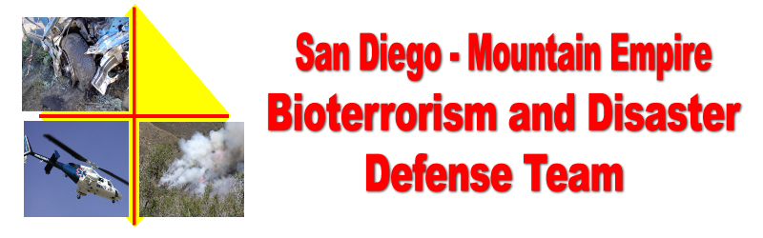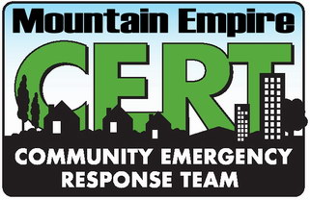
Disaster Preparedness Exercise
Campo, CA
Saturday, October 21, 2006
Operation CERT Background
This functional exercise will have four major components.
- CERT Teams – An accident has de-railed several passenger cars in the Carrizo George Rail Road (CGRR) Sand Operations yard, Campo CA. A school bus was also involved. Victims need assistance.
- American Red Cross (ARC) - Open the Campo Community Center, 976 Sheridan Road Campo, CA 91906 (619) 478-2384, as an area Red Cross Shelter to test our community Red Cross Volunteers.
- RACES – At the CGRR Sand Yard. Utilize ECHO III as the Area Incident Command and Community Communications Center.
- Community – Invited to the Community Center where they can participate in the ARC exercise and receive disaster preparedness information.

FUNCTIONAL EXERCISE OBJECTIVES

- Assist CERT Teams with a realistic drill scenario in the CGRR sand yard.
- Demonstrate the communities ability to operate a Red Cross Emergency Evacuation Center, following Red Cross Procedures and the Community Disaster Center Operations Procedures generated by the Mountain Empire Bioterrorism and Disaster Defense Team. Disaster preparation information will be available for the public.
- Demonstrate the ability to setup a Community Incident Command Communications Center in ECHO III.
- Test CERT, ARC and the Communities Disaster Volunteers ability to coordinate resources and communications between drill locations.
- Test the ability to coordinate resources and activities between local communities in the Mountain Empire Area and outside agencies.

THE EXERCISE SUMMARY AND ASSUMPTIONS

- A passenger train has crashed into a school bus at the CGRR Campo Yard.
- The Exercise will be broken up into three incidents. Rail car incident, bus incident, and ARC emergency shelter. Each incident will be controlled by a CERT Team Leader or ARC Incident Commander with the assistance of a Fire Department Safety Officer.
- Exercise Controllers may introduce additional problems to facilitate the level of exercise activity.

Should there be a real emergency or, injury or if you are uncomfortable with the way you are being handled during the exercise, the key phrase “This is a real world incident” will be used to clarify to the participants that you are not acting. If necessary the Safety Officer will contact the appropriate First Responders for assistance.

Victim Unit Responsibilities

- Under the direction of Logistics, procure volunteers to act as accident victims for the CERT Teams to rescue.
- During the drill the Victim Unit reports to the CERT Staging Area Manager. Number of victims needed will be determined by the CERT Operations Group prior to each exercise.
- Hold a training and instructional meeting, with the Logistics Group and CERT Coordinator, before the drill, to:
  - Insure everyone understands the purpose of the drill and has been instructed on proper safety procedures.
  - Practice the application of moulage. CERT Operations will provide “symptomology cards” that will be placed on each victims body that will identify the type and level of injury or distress.
  - Practice the level of “acting” required to simulate the various injury types. ( Do not overact or place yourself in a dangerous position. Acting should be passive to prevent the rescuer from injuring the victim.

The Victim Unit Leader will keep the Logistics Group informed of their progress during formation and training of the Victim Unit and look to Logistics for guidance and any supplies needed.

On Drill Day
As a “Victim” we ask that you be at the site Registration Area no later than 7:00 a.m. Some victim’s may finish and be released earlier than expected, but please plan to stay until at least 3:00 p.m. Please bring a valid photo to aid the registration process. Minors bring your parental permission slips. If you have any health concerns, medical conditions or require special accommodation, please indicate so when you register. All reasonable requests for accommodation will be made. This is an all volunteer effort so please be patient and follow all instructions.
Registration and Check-In, 0700 Hours. You must check-in at the Registration Area located in the Rail Yard parking lot. After you register, you will go through an orientation/safety briefing from the Victim Unit and Logistics Leads. If you have not already been provided one, during the registration process you will receive a “symptomology card”. This will provide you with information on how to behave for the purpose of the exercise. At the conclusion of the exercise, you will be asked to fill out a questionnaire. Your evaluation is critical to the evaluation of this exercise and we ask that you carefully and purposefully fill them out. Detailed instructions will be provided during the Victim Briefing on the morning of the exercise. After the briefing, you will be escorted to your assigned “disaster”.
Please act in accordance with your script - Don’t overact. It is very important to play your assigned role from the symptomology cards as best you can, but this does not mean you should overact. Overacting can be dangerous for yourself and the emergency workers in the exercise. There will also be a briefing about your roles and what will happen during the exercise. If you do not know how to play your role or have questions about the briefing, please ask the volunteer coordinator or assigned exercise controllers who are there to help. If you are assigned the role of a psychologically distressed person, please act upset, not out-of-control.
Exercise Safety In any exercise, safety is of the utmost concern. If you notice an unsafe condition or a situation that could become unsafe, please notify a Exercise Controller or Safety Officer (Firefighter) immediately. In the event of a real-world emergency, the appropriate phrase you should use is: “This is a real world incident.” Use of this phrase is very important, otherwise Controllers and those around you may not know you are not acting.

Wear layers of clothing and comfortable shoes. We will begin early in the morning when it is substantially cooler than it will be by the time you are released in the afternoon. The Logistics Group will provide old clothes to volunteers with extensive moulage. Wear layers of clothing that can be removed if you become too warm. Also, inclement (rainy) weather may be an issue on the day of the exercise so please plan accordingly (i.e. umbrella, rain coat, sunscreen, etc.).

Please bring only those items you will be comfortable holding and carrying for the duration of the exercise as there will be no place to keep any additional personal items. Water and lunch will be provided. Everyone participating will receive a free, event, t-shirt after the drill!
Bring your sense of humor. Do not bring items you do not want to carry for the duration of your participation, uninvited friends or volunteers.
If you have any questions, please contact your Logistics Group liaison.
Thank you again for your participation! Your time and effort will help to better prepare and ensure the readiness of you and your community to respond to an emergency.
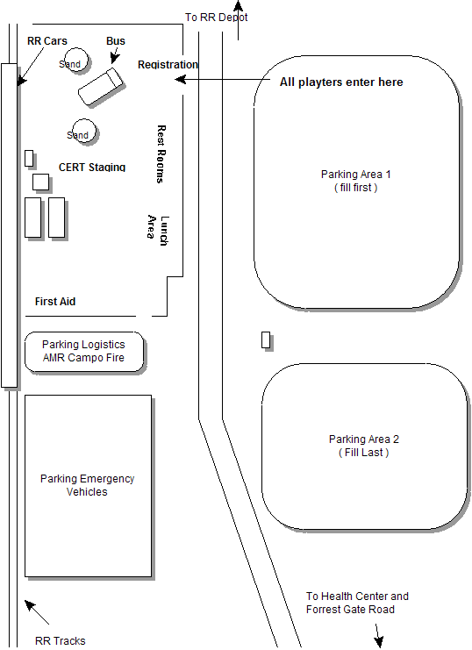
SITE MAP

AREA MAP

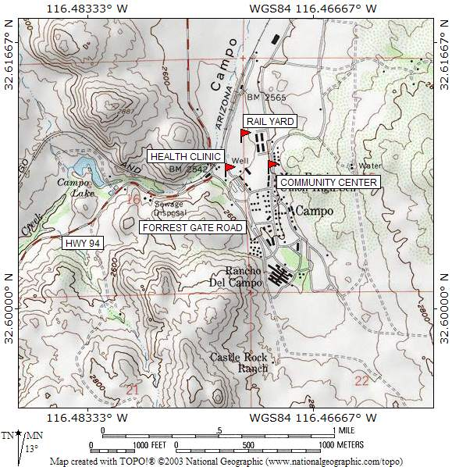

PARENTAL PERMISSION SLIP
REGARDING PARTICIPATION IN THE October 21, 2006,
REGIONAL CERT DRILL, CAMPO, CA

Name Of Student: ___________________________________

Address: ____________________________________________

City/State: ___________________________________________

Phone - Home: _______________________ Phone-Cell: ___________________________

As the parent or legal guardian of the above individual, I hereby give my approval for their participation in the CERT training drill on October 21, 2006, Campo California.

At the drill site an official from San Diego County Government will register all participants as a Disaster Service Worker. A Disaster Service Worker (DSW) is a volunteer who is registered with a disaster council and who, if activated and employed during an emergency or authorized event, is covered by workers compensation insurance by the employing government agency. (Section 8580 of the California Emergency Services Act)

____________________________________________________________________
SIGNATURE OF STUDENT DATE

____________________________________________________________________
SIGNATURE OF PARENT OR GUARDIAN DATE

