Operation CERT

Exercise Plan

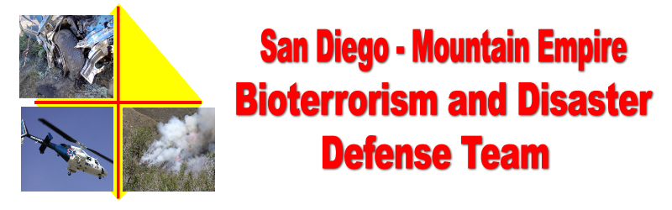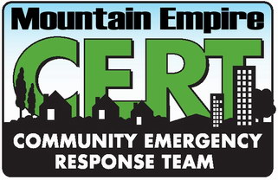
Disaster Preparedness Exercise
Campo, CA
Saturday October 21, 2006
Should a real emergency or injury occur during the exercise, the key phrase “This is a real world incident” will be broadcast to Incident Command, and the Safety Officer will contact the appropriate First Responders.
GOAL
The goal of this exercise is to:
- Provide an “in the field” exercise drill for the CERT Teams of San Diego County.
- Test Community Disaster Organizational Plans developed by the Campo / Lake Morena Disaster Committee, including opening an American Red Cross (ARC) Emergency Shelter.

EXERCISE CONCEPT

This functional exercise will have four major components.
- CERT Teams – An accident has de-railed several passenger cars in the Carrizo George Rail Road (CGRR) Sand Operations yard, Campo CA. A school bus was also involved. Victims need assistance.
- American Red Cross (ARC) - Open the Campo Community Center, 976 Sheridan Road Campo, CA 91906 (619) 478-2384, as an area Red Cross Shelter to test our community Red Cross Volunteers.
- RACES – At the CGRR Sand Yard. Utilize ECHO III as the Area Incident Command and Community Communications Center.
- Community – Invited to the Community Center where they can participate in the ARC exercise and receive disaster preparedness information.

FUNCTIONAL EXERCISE OBJECTIVES

- Assist CERT Teams with a realistic drill scenario in the CGRR sand yard.
- Demonstrate the communities ability to operate a Red Cross Emergency Evacuation Center, following Red Cross Procedures and the Community Disaster Center Operations Procedures. Disaster preparation information will be available for the public.
- Demonstrate the ability to setup a Community Incident Command Communications Center in ECHO III.
- Test CERT, ARC and the Communities Disaster Volunteers ability to coordinate resources and communications between drill locations.
- Test the ability to coordinate resources and activities between local communities in the Mountain Empire Area and outside agencies.

THE EXERCISE SUMMARY AND ASSUMPTIONS

- A passenger train has crashed into a school bus at the CGRR Campo Yard.
- The Exercise will be broken up into three incidents. Rail car incident, bus incident, and ARC emergency shelter. Each incident will be controlled by a CERT Team Leader or ARC Incident Commander with the assistance of a Fire Department Safety Officer.
- Exercise Controllers may introduce additional problems to facilitate the level of exercise activity.

EXERCISE CONTROL, Carrizo Gorge Sand Yard, Campo Community Center ARC Shelter

ECHO III will be setup as the Community Incident Command and Communications Center. Exercise Controllers will direct exercise challenges and coordination between the Community Center, and Rail Yard staging areas, by runners, 2-way radio, cellular telephone and/or land line telephone.

The schedule for the exercise is:

- 0600 – Logistics arrives to complete Sand Yard site setup.
- 0700 to 0800 – Moulage and Victim teams register, DSW swear in and prepare moulage.
- 0800 to 0845 – Registration at The Sand Yard Drill site and Community Center sites. CERT Teams setup and briefings at the Rail Yard, Community Center ARC setup, HAM and RACES Net checkins.
- 0845 to 0900 – Participants and CERT Go Trailers move to assigned staging areas.
- 0900 Safety briefing, DSW swear in, at all drill areas.
- 0930 to 1130 – CERT Teams participate in assigned exercises.
- 1100 – Lunch area open for those not currently drilling.
- 1130 to 1215 - Lunch break CERT Teams and support staff.
- 1200 – ARC Community Center exercise complete.
- 1215 till done – Lunch break Community Center participants.
- 1230 to 1430 – CERT Teams participate in assigned exercises.
- 1430 ASTREA safety training.
- 1500 CERT Drill finished. Cleanup.

EVALUATION / CRITIQUE

Exercise / Drill evaluation forms will be available for anyone to fill out to assist us in evaluating this drill and to assist in preparing future exercises.

SAFETY AND SECURITY

A fire unit and American Medical Response BLS or ALS unit will be assigned exclusively to drill safety.
Law enforcement will be responsible for traffic control and security.

Should a real emergency or injury occur during the exercise, the key phrase “This is a real world incident” will be broadcast to Incident Command, and the Safety Officer will contact the appropriate First Responders.

COMMUNICATIONS

Runners
Runners may be used for the movement of messages and resource requests between CERT Teams, Cert Operations and staging.

Telephone
Land line and cellular telephone lists will be provided to ECHO III IC prior to the beginning of the exercise. In the Campo area Verizon provides the best cellular coverage. Contacts and phone numbers will be included in the Incident Radio Communications Plan.

Drill Radio Frequencies
In addition to the frequencies below teams may use other frequencies to communicate between team members and their Team Leaders. Teams will work with CERT Operations and ECHO III IC on frequency assignments. CERT Operations will then advise ECHO III IC of assigned frequencies, for inclusion in the Incident Radio Communications Plan, prior to 0845.

Upon completion of a radio message or request for resources the originating station shall broadcast “this is a drill”.

At drill sites Campo
- Family Service portable radios (FRS) Channels as assigned by the Incident Radio Communications Plan. Use the diagram below as a guide when setting up your teams communication plan.
- Amateur Radio National Simplex, primary Tactical 146.520 MHz. Others as assigned.
- First responder and law enforcement as assigned by their agencies and ECHO III.

Between ECHO III IC, San Diego County EOC, and Communities, Amateur Radio (HAM)
- Primary, Community - Lyons Peak, SANDRA, TX-146.865 /RX-146.265, PL 107.2
- Secondary 1, Campo Boulevard, White Star, SANDRA, TX-144.68 /RX-145.28, PL 107.2
- Secondary 2, Otay Mountain, SANDRA, TX-146.04 /RX-146.64, PL 107.2
- Primary RACES, EOC, RED 1, TX-147.795 /RX-147.195, PL 114.8. A voted system.

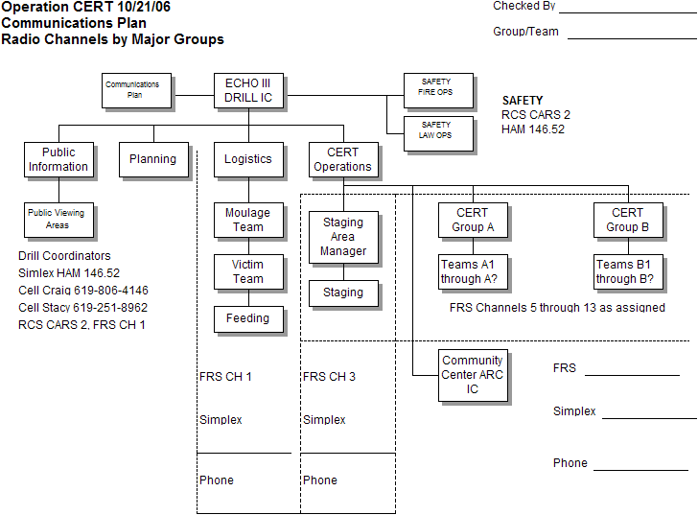
AGENCIES PARTICIPATING

Mountain Empire Disaster Defense Team. Mountain Empire CERT Teams
www.campofire.org/disaster

Campo Fire and Rescue
www.campofire.org

San Diego County, Office of Emergency Services CERT Teams
http://www.co.san-diego.ca.us/oes/community/get_involved/cert/

Radio Amateur Civil Emergency Service (RACES)
http://www.races.sandiego.ca.gov/races/

San Diego / Imperial County, American Red Cross
http://www.sdarc.org

Carrizo Gorge Railway, Inc.
http://www.carrizogorgerailway.com

Pacific Southwest Railway Museum
http://www.psrm.org

California Department of Forestry and Fire Protection
http://www.fire.ca.gov/php/

San Diego County Sheriff, Campo Station
http://www.sdsheriff.net/rural/substations_campo.html

U.S. Border Patrol Explorer Scouts

U.S. Border Patrol, Campo Station

NOTES AND DISCUSSION

Organization. The planning and operational portions of the drill will be organized under the National Incident Management System (NIMS) model. CERT Teams will use learned CERT procedures and structures which differ slightly from the standard NIMS / ICS model.

Safety. An overall incident safety officer will be appointed. They may assign as many personnel as required to insure safety at each incident location.

Fire and Law Enforcement Agencies. A primary contact person will be assigned from each agency participating and be based at the ECHO III Van. This person will act as the coordinator between their agency and the drill planning and operations staff.

Medical. An ALS or BLS unit from American Medical Response (AMR) will be dedicated to the drill.

Mountain Empire High School, drama club and Kiwanis Key Club, plus members from the Mountain Empire Area, will provide victims and apply moulage to victims. Coordinated by the Drill Logistics Group.

The Freedom Ranch will assist the Logistics Branch with meals and water distribution.

The Border Patrol Explorers and their advisors will assist SDSO and CHP with traffic control and parking.

AREA MAP
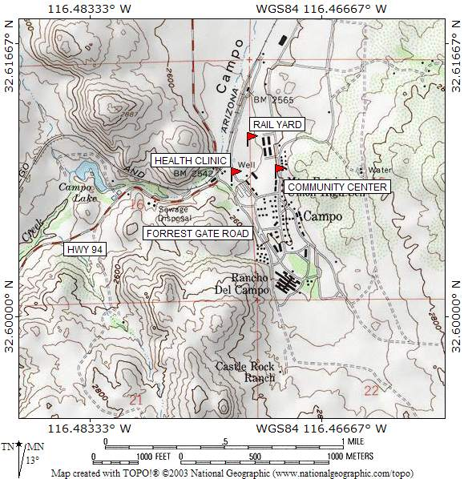

Take Interstate 8 to the Buckman Springs turnoff. Go South. At Highway 94 ( Buckman Springs dead end ) Turn right (West). At RR Tracks turn left to Forrest Gate Road. Take first dirt road to the left. Watch for border Patrol Explorer Scouts, traffic control.

Take Highway 94 East from Rancho San Diego. At Campo turn right on Forrest Gate Road.

Community Center. Continue on Forrest Gate to first paved road, Jeb Stewart. (Jeb Stewart is not signed. It is the paved road that runs in front of the Border Patrol Station.) Turn left on Jeb Stewart to dead end on Sheridan Road. Left on Sheridan to second building, Community Center. Parking at lot on hill, North East of the Center. First driveway on the right as you pass the Community Center. Watch for Border Patrol Scouts for directions.

Talk in frequencies. RCS 800 CARS 1. Ham 146.52 simplex and Lyons Peak, SANDRA, TX-146.865 /RX-146.265, PL 107.2. Cell Craig Williams 619-806-4146.

Detail, Drill and Parking Area
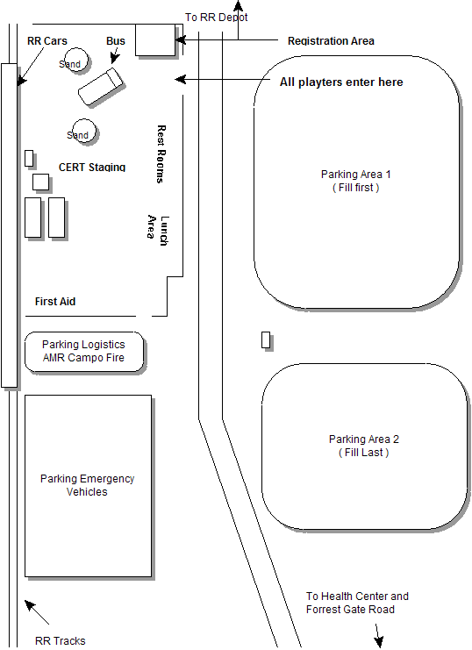

Detail, Drill Area

