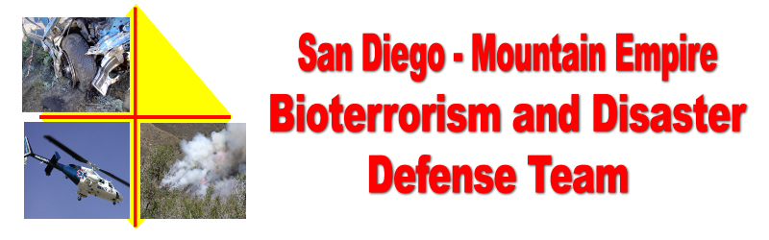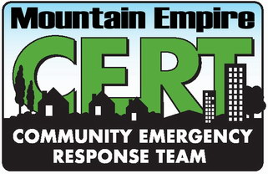
DRILL Operation CERT - Evaluation form – October 21, 2006
(Use the back of this form or additional sheets if required for additional comments or observations)

The objectives of this drill were to:
- Provide an “in the field” exercise drill for the CERT Teams of San Diego County, to test their skills and performance, in a disaster situation.
- Test Community Disaster Organizational Plans developed by the San Diego County, Office of Emergency Services, and the Campo / Lake Morena Disaster Committee, including opening an American Red Cross (ARC) Emergency Evacuation Shelter.
Which drill location did you participate in?

__RACES. __CERT Drill Site. __Red Cross Shelter. _________________________________________Other

As you observed or participated, what was your opinion of the participants ability to complete the above objectives?

What was missing in the drill that hindered a more successful outcome? More training? More resources?

Any other comments or observations you may have?

Return this evaluation to

