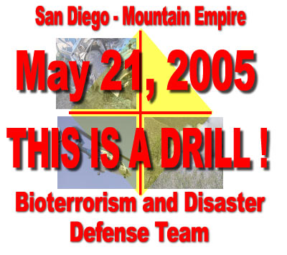 | May 21, 2005. Disaster Preparedness Drill  Operation Animal  Envelope #1.

Time 0900 to 0930.
ALL MESSAGE TRAFFIC BEGINS AND ENDS WITH THE STATEMENT “ THIS IS A DRILL”

At 0800 hours this morning a grass fire has broken out near the Mexican border, South East of Terra Del Sol Road. (N32°.36.203' W116°.18.442') Winds are 5 to 10 miles per hour out of the South East. By 0900 hours the fire has reached a size that the CDF Incident Commander has asked Campo Fire and Boulevard Fire to initiate their Community Disaster Plans and prepare to evacuate animals and residents in their respective communities.
Fire Incident Command is CDF, Callsign, Tierra IC.

The following is completed between 0900 and 930 hours.

The Campo / Lake Morena area Communications Command is setup in ECHO III, parked across from the Campo Fire Station 86. Tactical Callsign ECHO III.
The Community Incident Commander is based in ECHO III, Tactical Callsign Campo IC.
- Incoming personnel sign in on Personnel Resource Log.
- RACES Operator Position established. RACES operator prepares for RACES Net checkins after the HAM Net at 0900.
- ARR Dispatch Position established. ARR Operator Prepares to dispatch resources.
- HAM Dispatch Position established to coordinate HAM radio frequency traffic.

An assembly area for Animal Rescue Reserve (ARR) and Humane Society vehicles and personnel is established on Sheridan Road in the Thrift Shop parking area. Tactical Callsign ARR Staging.
- Incoming personnel sign in on Personnel Resource Log.
- ARR Staging advises ECHO III, ARR Dispatch, on resource availability.
- ARR prepares to dispatch vehicles for animal rescue.

The Campo Community Center is opened. Tactical Callsign Campo Center.
- Incoming personnel sign in on Personnel Resource Log.
- An Amateur Radio Station is setup.
- Campo Center advises ECHO III HAM dispatch of their status.

The Flying A Ranch opens and organizes as an Animal Rescue Receiving Center. Tactical Callsign Flying A.
- An Amateur Radio Station is setup as the Lyons Drill Net Control at the Flying A and begins the Lyons HAM Net checkins.
- Volunteers at the Flying A Ranch are signed in on the Personnel Resource Log and assigned tasks, determined by the Ranch Command. Ranch prepares to receive large animals and their owners.
- The Flying A Ranch advises the ECHO III, HAM Dispatch, on status and resources.

All messages between sites should be documented on the 5 part Message Form
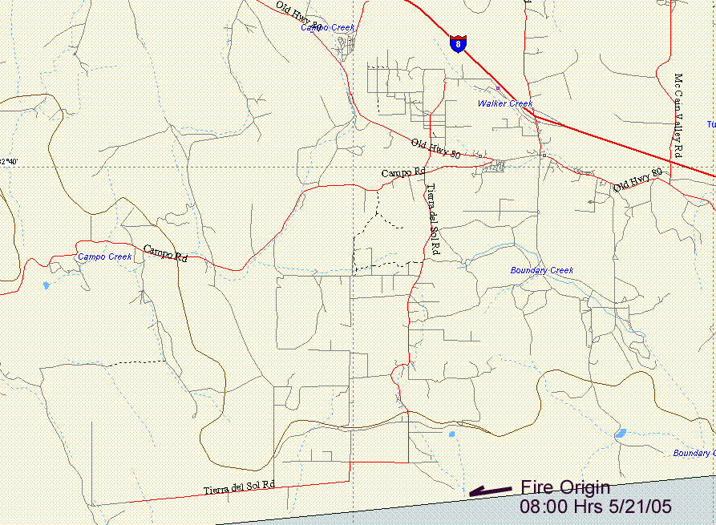

FIRE ORIGIN MAP

May 21, 2005. Disaster Preparedness Drill
Operation Animal
Envelope #2.

Time 0930
ALL MESSAGE TRAFFIC BEGINS AND ENDS WITH THE STATEMENT “ THIS IS A DRILL”

Reference the Fire Line Detail Map. CDF Tierra IC advises the wind DIRECTION REMAINS OUT OF THE South East. Winds are expected to calm in the next 30 minutes. The fire is running North West with the head of the fire in the Terra Del Sol area. The fire is estimated 30% contained with full containment estimated by 2000 hours. SDSO has issued evacuation orders to residents from the Shockey Truck Trail area East to Manzanita on the North. Residents are advised of the evacuation center at the Campo Community Center and the Boulevard Community Center. Residents with large animals are advised to take their animals to the evacuation center at the Flying A Ranch.

ARR Staging. Instructions are coming in from the ECHO III, ARR Dispatcher, on locations of ranches in the area needing large animal evacuation assistance. Assign and dispatch your units as you see fit. Advise ECHO III, ARR Dispatch as each team is dispatched with Team Tactical Callsign, location dispatched to. ( Keep detailed records of team member names, vehicle license numbers and any other information you deem necessary for the safety of the teams.) Simulate animal transport to the Flying A Ranch evacuation site and process in your animals and any owners.

Campo Community Center. SDSO advises to expect up to100 evacuees from the fire area. Community Center Logistics Chief. Prepare the facility to receive 100 evacuees. Meet with Section Chiefs to plan resources and personnel assignments to handle the expected evacuees. Notify Echo III to update Red Cross and RACES representatives on the situation.

Flying A Ranch, Incident Command. SDSO has advised to expect a number horses and assorted owners at the Ranch. Details will be provided by ECHO III through your Communications Section. Flying A Ranch Command to meet with their team leaders and plan resources and personnel assignments to handle the expected evacuees.

All messages between sites should be documented on the 5 part Message Form

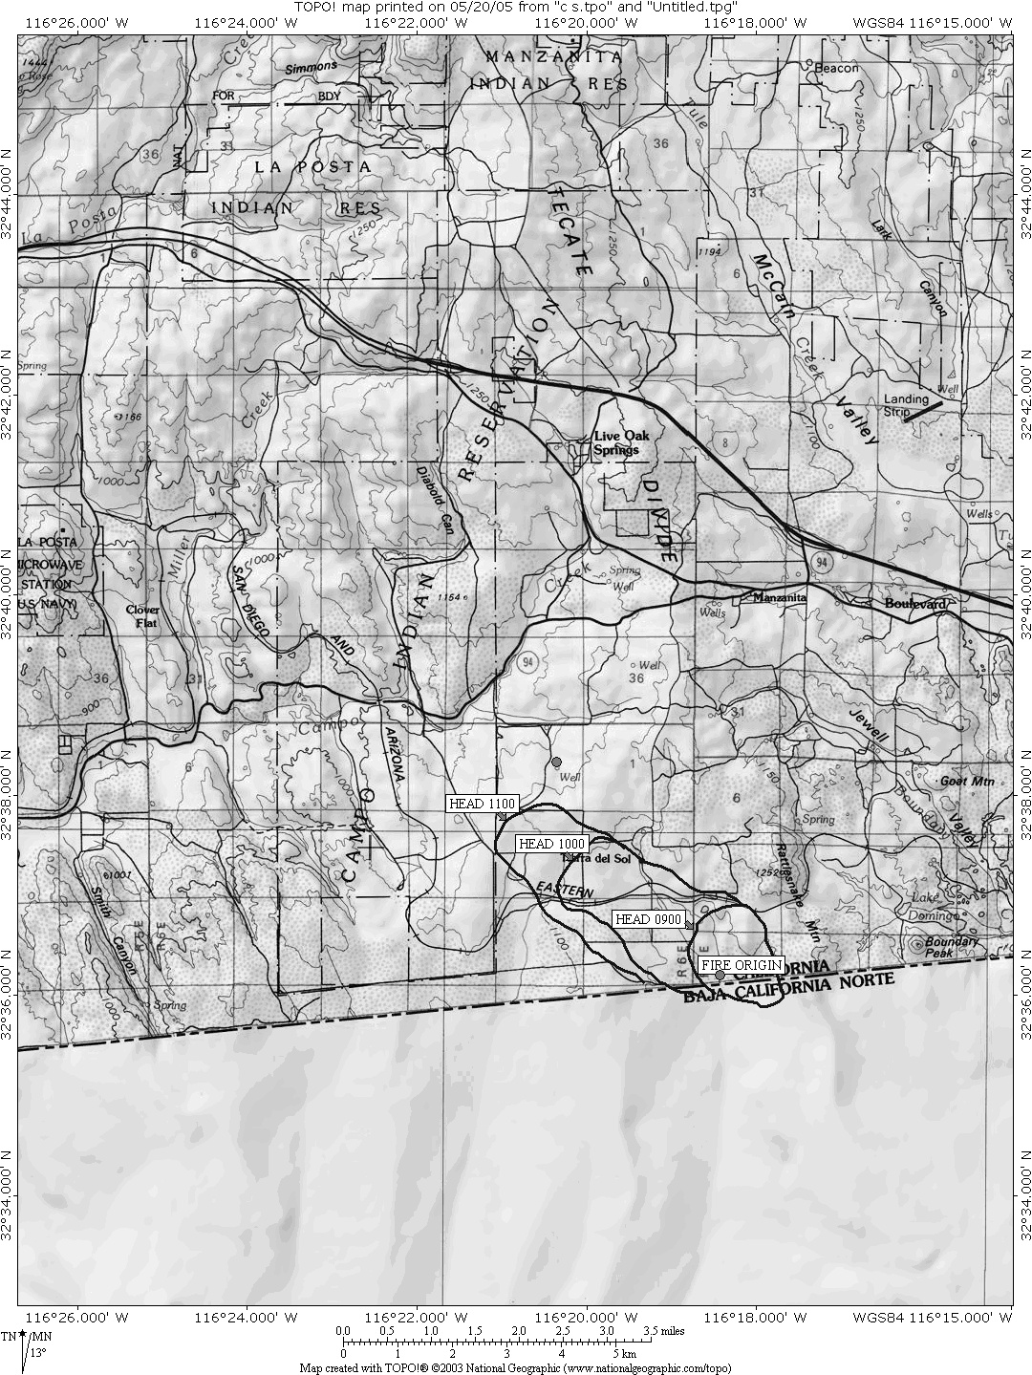

FIRE LINE DETAIL MAP

May 21, 2005. Disaster Preparedness Drill
Operation Animal
Envelope #3.

Time 1100
ALL MESSAGE TRAFFIC BEGINS AND ENDS WITH THE STATEMENT “ THIS IS A DRILL”

Reference the Fire Line Detail Map. CDF Tierra IC advises the wind DIRECTION REMAINS OUT OF THE South East. Winds are now calm. The fire advance has slowed. Estimated 50% contained with full containment estimated by 2000 hours.

No new evacuation areas have been ordered.

Due to excessive heat and loading a power transformer has blown at the Buckman Springs Road, SDG&E substation. All power is out in the Lake Morena Campo area. Units must operate without using SDG&E power, that is, battery, vehicle or generator power, for the remainder of the drill.

Verizon and Cingular Cell sites are down. The power outage has taken the Verizon and Cingular sites down. (They never check their battery backup out here in the sticks!) No cell phone usage for the remainder of the drill.

All messages between sites should be documented on the 5 part Message Form

1145 Hours. Exercise Complete.
1200 Hours. All meet at the Community Center for Overall Critique and CDF Fire Safety Presentation

