Operation Animal

Exercise Plan

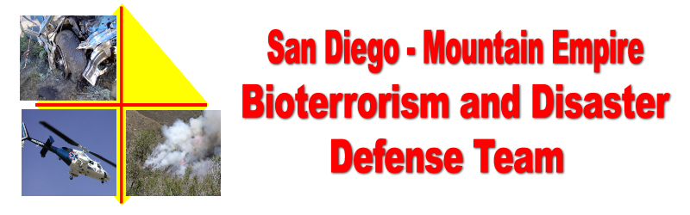
Disaster Preparedness Exercise
Campo, CA
May 21, 2005
Should a real emergency or injury occur during the exercise, the key word “MEDIC” will be broadcast to Incident Command, and the Safety Officer will contact the appropriate First Responders.

As this is a drill we will be making up things as we go along. Example, when you get a request for resources check with the drill team members who may have expertise in the area of the request and “invent” a plausible answer to fill the request.

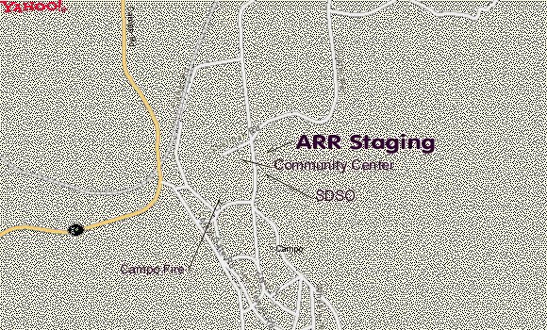  See last page for an aerial of the Flying A Ranch | 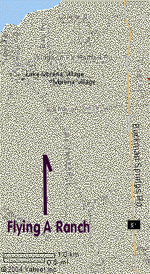
GOAL
The goal of this exercise is to test Community Disaster Organizational Plans, and the communications capabilities of local communities in the Mountain Empire Area of San Diego County, and to Assist the San Diego Humane Society and the Animal Rescue Reserve in their Campo Area, Animal Rescue Drill. The Mountain Empire Area includes communities on Highway 94 from Jamul through Jacumba, on Interstate 8 from Descanso through Jacumba, and South from the Mount Laguna area to the International Border.
AGENCIES PARTICIPATING

Mountain Empire Disaster Defense Team. Mountain Empire CERT Teams
www.campofire.org/disaster
Campo Fire and Rescue
www.campofire.org
The San Diego Humane Society's Animal Rescue Reserve (A.R.R.)
http://www.sdhumane.org/programs/animalrescuereserve.cfm
County of San Diego, Animal Services
http://www.sddac.com/
Radio Amateur Civil Emergency Service (RACES)
http://www.races.sandiego.ca.gov/races/
California Department of Forestry and Fire Protection
http://www.fire.ca.gov/php/
San Diego County Sheriff, Campo Station
http://www.sdsheriff.net/rural/substations_campo.html
U.S. Border Patrol Explorer Scouts
U.S. Border Patrol, Campo Station

EXERCISE CONCEPT.

This functional exercise will have four major components.
- Open the South gate and Barn area of the Flying A Ranch, 1880 Lake Morena Dr, Campo, CA 91906 (619) 478-9144, as the Animal Rescue Receiving Center.
- Open the Campo Community Center, 976 Sheridan Road Campo, CA 91906 (619) 478-2384, as an area Evacuation Center to test our Logistics Committee and CERT Team disaster response procedures.
- Open the Campo Fire and Rescue Fire Station, 437 Jeb Stuart Road, Campo, CA 91906 (619) 478-5310, as the Incident Command and Community Communications Center. (Communications Center is RACES 1, parked at the Fire Station)
- Setup Animal Rescue Staging area located in the Homemakers Thrift Shop parking area across from and North of the Community Center.

This will be an “in place” exercise. Except for the Humane Society / ARR component, there will be no movement of people or equipment after the start of the exercise.

FUNCTIONAL EXERCISE OBJECTIVES

- Assist the Humane Society / ARR with mapping, communications and dispatch of their units, to local ranches, where they can test their ability to rescue large animals during a disaster.
- Demonstrate the communities ability to operate an Emergency Evacuation Center, following the Community Disaster Center Operations Procedures generated by the Mountain Empire Bioterrorism and Disaster Defense Team. Disaster preparation information will be available for the public.
- Demonstrate the ability to setup the Logistics for an animal evacuation center at a local ranch. Animal Rescue staging area located in the Homemakers Thrift Shop parking area across from and North of the Community Center.
- Demonstrate the ability to setup a Community Incident Command Communications Center at the Campo fire Station, Station 86.
- Test the communities ability to coordinate resources and communications between remote locations.
- Test the ability to coordinate resources and activities between local communities in the Mountain Empire Area.
THE EXERCISE SUMMARY AND ASSUMPTIONS

- At 0800 hours this morning a grass fire has broken out near the Mexican border, South East of Terra Del Sol Road. (N32°.36.203' W116°.18.442') Winds are 5 to 10 miles per hour out of the South East. By 0900 hours the fire has reached a size that the CDF Incident Commander has asked Campo Fire and Boulevard Fire to initiate their Community Disaster Plans and prepare to evacuate animals and residents in their respective communities.
- The Exercise will be conducted in compressed time. The events will be broken up into 3 segments, each of which will be introduced by the opening of a scenario envelope at a specific time indicated on each envelope.
- Exercise Controllers may introduce additional messages to facilitate the level of exercise activity.

EXERCISE CONTROL, Campo Area

RACES 1, at the Campo Fire and Rescue Fire Station, will be setup as the Community Incident Command and Communications Center. Exercise Controllers will direct exercise challenges and coordination between the Community Center, Animal Rescue staging area, and the Flying A Ranch by 2-way radio, cellular telephone and/or land line telephone.

The schedule for the exercise is:

- 0900 to 0930 – Setup and exercise briefings at the Community Center, the Campo Fire Station, the Flying A Ranch, and the Animal Rescue staging area. HAM and RACES Net checkins.
- 0930 – Open Animal Evacuation Scenario, envelope #1. Begin dispatch of Animal Rescue Units
- 1030 – Open Community Evacuation Scenario, envelope #2.
- 1045 – Open Scenario envelope #3.
- 1200 - 1330 Meet at the Community Center for overall exercise evaluation and fire safety presentation by the California Division of forestry (CDF). All parties and community members are invited to attend.

EVALUATION / CRITIQUE

Exercise / Drill evaluation forms will be available for anyone to fill out to assist us in evaluating this drill and to assist in preparing future exercises.

SAFETY AND SECURITY

The Disaster Center Command System (DCCS) Operations Chief and Safety Officer, for this Exercise, will be the Incident Commander, Craig Williams, Public Affairs Officer, Campo Fire and Rescue with the assistance of the assigned Campo Firefighter / EMT.

Should a real emergency or injury occur the key word “MEDIC” will be broadcast to Incident Command and the Safety Officer will contact the appropriate First Responders.

COMMUNICATIONS

Telephone
Land line and cellular telephone lists may be provided prior to the beginning of the exercise.

Radio Frequencies.
On site Campo – Campo Fire Station, Community Center, and Flying A Ranch
- FRS Channel #1. Family Service portable radios (W/T)
- Amateur Radio National Simplex, 146.520 MHz
Between Campo Fire Station, Community Center, and Flying A Ranch
- Amateur Radio National Simplex, 146.520 MHz.
- “Red Dot” low power VHF, 151.625 MHz. ( Also monitored by Campo Fire and Rescue as the S86 frequency on the Kenwood VHF radios.)
Between Sites and Communities
- Primary HAM - Lyons Peak, SANDRA, TX-146.865 /RX-146.265, PL 107.2
- Backup, Campo Boulevard, White Star, SANDRA, TX-144.68 /RX-145.28, PL 107.2
- Backup HAM Otay Mountain, SANDRA, TX-146.04 /RX-146.64, PL 107.2
- Primary VHF - RACES,RED 1, TX-147.795 /RX-147.195, PL 114.8. A voted system.
- ARR Primary – G7 Repeater TX-159.135 /RX-155.715, PL 131.8, Los Pinos Site
- ARR – G1 Simplex TX/RX 154.54, PL 107.2

First Responders, Animal Rescue and other County Agencies participating will advise the Exercise Controllers of their communications capabilities and requirements for the Exercise.

