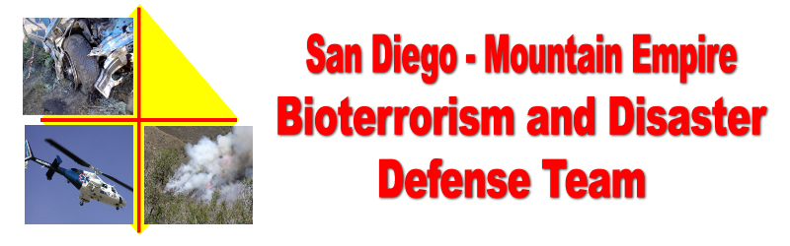
DRILL Operation Animal - Evaluation form – May 21, 2005
(Use the back of this form or additional sheets if required for additional comments or observations)
The objectives of this drill were to:
- Test the communities ability to open and organize disaster / evacuation centers for people and large animals and work with the Humane Society and the Animal Rescue Reserve during a mock disaster.
- Effectively communicate disaster information between the centers, local communities and agencies outside the immediate drill area.

Which site did you observe or participate in?
__RACES 1. __Campo Community Center. __Flying A Ranch. __ARR. ________________Other

As you observed or participated, what was your opinion of the participants ability to communicate their needs during a disaster and complete the assigned tasks at your location.

How do you think the participants could improve their ability to perform the above?

What was your observation of the communities abilities to communicate between the centers and between communities and agencies outside the immediate drill area.

How do you think the community could improve its ability to perform the above?

Return this evaluation to

