Operation Empire

Exercise Plan

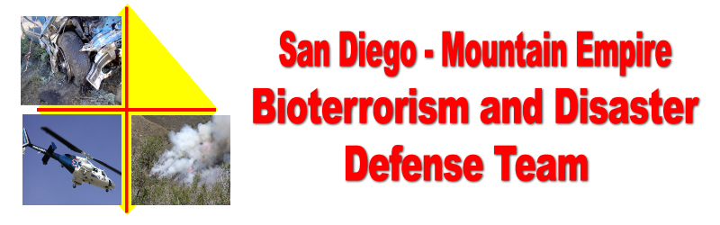

Disaster Preparedness Exercise
June 26, 2004

Should a real emergency or injury occur during the exercise, the key word “MEDIC” will be broadcast over all Exercise Communications channels, and the Safety Officer will contact the appropriate First Responders.

As this is a drill we will be making up things as we go along. Example, when you get a request for resources check with the drill team members who may have expertise in the area of the request and “invent” a plausible answer to fill the request.

GOAL
The goal of this exercise is to test Community Disaster Organizational Plans, and the communications capabilities of local communities in the Mountain Empire Area of San Diego County.

The Mountain Empire Area includes communities on Highway 94 from Jamul through Jacumba, on Interstate 8 from Descanso through Jacumba, and South from the Mount Laguna area to the International Border.

BACKGROUND

During the wild fires of October 2003 several communities in the Mountain Empire Area were used as disaster evacuation locations for displaced people and animals. An after action analysis of these operations showed a need to put in place additional plans and resources, prior to the next disaster, be it in our area or in other areas where we are again used as an evacuation point.

EXERCISE CONCEPT, Campo – Lake Morena Areas

Since October 2003, the Mountain Empire Bioterrorism and Disaster Defense Team has prepared a set of operational plans and procedures to aid local communities in organizing their disaster preparedness efforts. These plans and procedures are available on the World Wide Web at www.campofire.org/disaster .

This functional exercise will have two major components.
- Open the Campo Community Center, 976 Sheridan Road Campo, CA 91906 (619) 478-2384, as an Emergency Operations Center / Evacuation Center to test our disaster response procedures.
- Open the Flying “A” Ranch, 1880 Lake Morena Dr, Campo, CA 91906 (619) 478-9144, as an animal evacuation point.

This will be an “in place” exercise. There will be no movement of people or equipment after the start of the exercise.

FUNCTIONAL EXERCISE OBJECTIVES

- Demonstrate the communities ability to operate an Emergency Operations Center, following the Community Disaster Center Operations Procedures generated by the Mountain Empire Bioterrorism and Disaster Defense Team.
- Demonstrate the ability to setup an animal evacuation center at a local ranch.
- Test the communities ability to coordinate resources and communications between remote locations.
- Test the ability to coordinate resources and activities between local communities in the Mountain Empire Area.

THE EXERCISE SUMMARY AND ASSUMPTIONS

- At 0800 hours this morning a grass fire has broken out in Mexico, 10 miles from the International Border, due South of Terra Del Sol Road. Winds are 5 to 10 miles per hour out of the South East. At 0900 hours the fire has crossed the International border. The CDF fire Incident Commander has asked Campo Fire and Rescue to initiate its Community Disaster Plan.
- The Exercise will be conducted in compressed time. The events will be broken up into 4 segments, each of which will be introduced by the opening of a scenario envelope at a specific time indicated on each envelope.
- Exercise Controllers may introduce additional messages to facilitate the level of exercise activity.

EXERCISE CONTROL

The Campo Community Center will serve as the Emergency Operations Center. Exercise Controllers will direct exercise challenges and coordination between the Community Center and the Flying A Ranch by land line telephone, cellular telephone and 2-way radio.

The schedule for the exercise is:

- 0900 to 0930 – Exercise briefing, by Exercise Controllers at the Community Center and Flying A Ranch.
- 0930 – Open Scenario envelope #1.
- 1000 – Open Scenario envelope #2.
- 1030 – Open Scenario envelope #3.
- 1045 – Open Scenario envelope #4.
- 1115 – 1145 Exercise Critique at the Community Center and Flying A Ranch.
- 1200 - 1300 Exercise Controllers meet at the Community Center for overall exercise evaluation. All parties and community members are invited to attend.

EVALUATION / CRITIQUE

Exercise / Drill evaluation forms will be available for anyone to fill out to assist us in evaluating this drill and to assist in preparing future exercises.

SAFETY AND SECURITY

The Disaster Center Command System (DCCS) Operations Chief and Safety Officer, for this Exercise, will be the Senior Exercise Controller, Craig Williams, Support and Communications, Campo Fire and Rescue.

Should a real emergency or injury occur the key word “MEDIC” will be broadcast over all Exercise Communications channels and the Safety Officer will contact the appropriate First Responders.

COMMUNICATIONS

Telephone
Land line and cellular telephone lists will be provided prior to the beginning of the exercise.

Radio Frequencies.
On site - Community Center and Flying A Ranch.
- FRS Channel #1.
- Amateur Radio National Simplex, 146.520 Mhz
Between sites
- Amateur Radio National Simplex, 146.520 Mhz.
- “Red Dot” low power VHF, 151.625 Mhz. ( Also monitored by Campo Fire and Rescue as the S86 frequency on the Kenwood VHF radios.)
Between sites and communities
- Amateur Radio Repeaters
  - Otay Mountain, SANDRA, 146.04 /.64, PL 107.2
  - Lyons Peak, SANDRA, 146.865 /.265, PL 107.2
  - RACES, RED 1, voted system.

First Responders, Animal Rescue and other County Agencies participating will advise the Exercise Controllers of their communications capabilities and requirements for the Exercise.

