COMMUNITY DISASTER DRILL - OPERATION EMPIRE JUNE 26, 2004 - AREA MAP
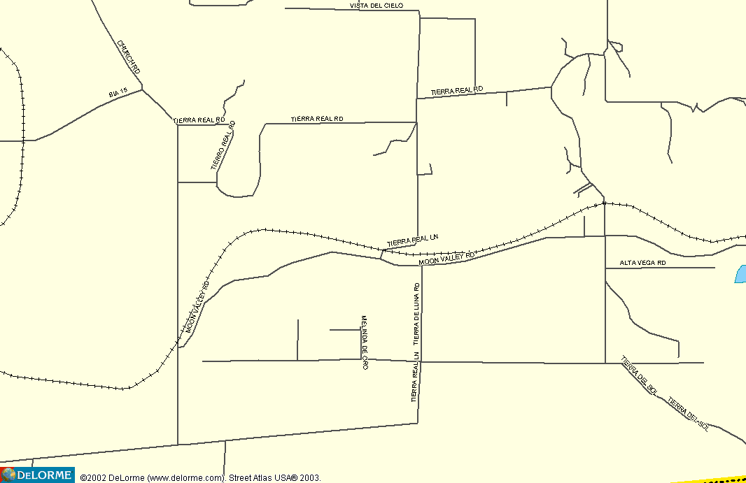

Detail Map, Tierra Del Sol Fire Area
COMMUNITY DISASTER DRILL - OPERATION EMPIRE JUNE 26, 2004

