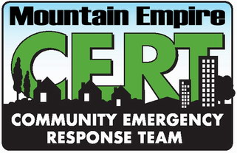 | Map and Compass Reading for CERT Operations  Prepared by: Craig Williams, Campo Fire and Rescue

Map Basics
From: http://www.compassdude.com/map-reading.shtml
Reading maps is not usually difficult because there are some rules that are generally followed when creating and reading maps:
- North, South, East, and West are the four main "cardinal" directions.
- On a map, North is at the top, South at the bottom, West to the left, and East to the right.
- Every map has a Map Scale which relates distance on the map to the world. For example, one inch equals one mile.
- Using the scale of a map, you can tell the actual distance between two points for real.
- Maps use map symbols to represent real-world things, such as buildings, trails, roads, bridges, and rivers.
- Maps use colors to share more information. Blue often means water, green means forest, and white means bare land.
- A map has a Legend which lists the symbols it uses and what they mean.
- A grid of imaginary lines wrap around and over the earth. These lines are called Latitude and Longitude and can identify the exact location of any point on earth.
Keeping those things in mind, you can read pretty much any map and especially learn how to read a topographic or TOPO map for navigation in the back country.

The Axis
Our coordinate system is going to be based on the spinning earth. The earth spins around on its axis. One end of the axis is the North Pole and the other is the South Pole. These are the two most important points on earth as far as directions and navigating are concerned.
The most important number for figuring out locations is 360. There are 360 degrees in a circle and that is the shape of our world, no matter how you slice it.

Latitude
If you could stand at the center of the earth, you could look out at the surface of the earth all around you. With the North Pole directly above your head, if you looked straight ahead in any direction, you would be looking at the equator. This imaginary line is exactly halfway between the north and south poles and has a latitude of 0 degrees because you are looking straight ahead at an angle of 0 degrees. If you look up a bit, maybe at an angle of 30 degrees, you have increased your latitude to 30 degrees North. Continue to look up higher and higher until you are looking straight above you at the north pole which is 90 degrees North.
Maybe this image will help:
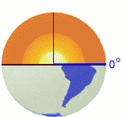
The same thing happens if you look down under the equator. The degrees increase until you are looking straight below you at the south pole which is at 90 degrees south latitude.
Just like the equator is a line drawn around the earth at 0 degrees latitude, you can draw a line around the earth at any latitude. Draw a lot of these lines and you will see something like this:
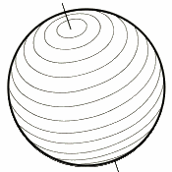
90 degrees north and 90 degrees south are actually just points, not circles. Notice that each latitude is parallel to all others. The actual distance between latitudes is always the same. But, since greater latitudes are closer to the poles, circumferences get smaller as latitudes increase.
Drawing those latitude lines onto a map would look like this:
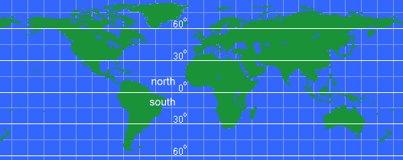

Longitude
Longitude is the angle east or west around the earth, just like latitude is the angle north and south. Longitude lines are called meridians.
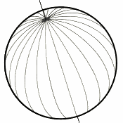
For latitudes, we have two fixed points - the north and south poles - that we use as end points. But, going around the earth, there is no start or stop, it just keeps spinning and spinning. So, an arbitrary spot was chosen to be the Start point for longitudes. This spot is the Royal Observatory in Greenwich, UK. The longitude line that runs through it is called the Prime Meridian and is longitude zero degrees.
Notice that longitude lines are not parallel. The closer to the poles you get, the shorter the distance between meridians until they all actually converge at the poles.
Drawing those longitude lines onto a map would look like this:
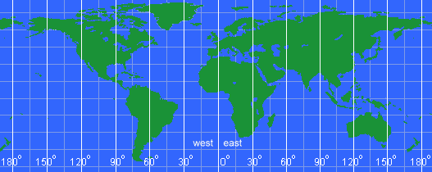

Latitude and Longitude Grid
Combining latitude and longitude results in a grid that covers the globe. Every point can be defined by a north/south degree and an east/west degree.
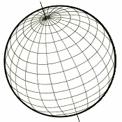
For example, Seattle, Washington, USA is at latitude 47.6° North and longitude 122.33° West. From the center of the earth, look up 46.6° from the equator and turn right (west) 122.33° from the Prime Meridian and you will be looking right at Seattle.
And, the complete grid on a map looks like:
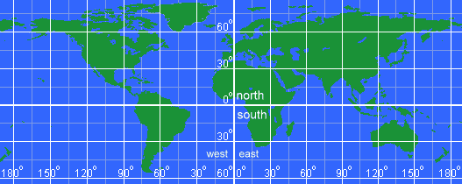
Well, degrees are fine and good, but the earth is almost 25000 miles around so dividing that into 360 pieces means each degree is about 69 miles wide around the equator. That isn't very precise. To help with that, each degree is divided into 60 minutes and each minute is divided into 60 seconds. These used to be used all the time, but now fractional degrees are more common.
For example, the location of the White House in Washington, DC is:
 | Decimal Degrees | Deg:Min:Sec
Lat: | 38.898648N | 38° 53' 55.133"N
Lon: | 77.037692W | 77° 02' 15.691W
USGS topographic maps are called 7.5 minute maps because they span 7.5 minutes of latitude and 7.5 minutes of longitude. The most common latitude and longitude map is a 1:24,000 scale and the actual map size is about 22 inches by 27 inches. By the way, it takes about 57,000 of these maps to cover the entire US and you can buy any of them you want. Start your collection today! :-)
That's about all there is to latitude and longitude coordinates! Here's some tips to remember:
- Latitude is always given before longitude (49° N 100° E)
- Latitudes are parallel, but longitudes are not
- Degrees West and South are sometimes referred to as negative degrees (-12° -23° is the same as 12 S 23 W)
- A place's latitude effects its climate, but not its longitude
- Key longitude lines are the Prime Meridian (o°) and the International Date Line (180°)
- Key latitude lines include the equator (0°), tropic of cancer (23° 26' N), tropic of Capricorn (23° 26' S), the arctic circle (66° 33' N), and the Antarctic circle (66° 33' S)

Basic Map Parts
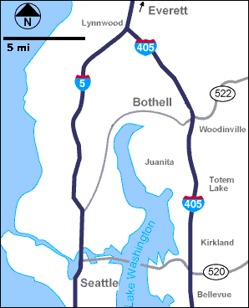
This simple road direction map contains a lot of information:
  - North is marked in the upper-left corner so you know which way this map relates to the world.
  - The Scale is marked. One inch equals 5 miles, so you can tell it is about 15 miles from Seattle to Woodinville.
  - Main roads are included so you can find the best route direction between two locations.
  - Roads are labeled so you know what to look for when navigating.
  - Bodies of water are colored blue.
So, you can see even a simple road map is packed with good direction and navigation information. The maps we use for hiking are even more packed with details.

Maps or Photos

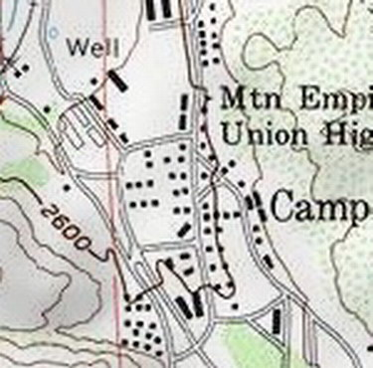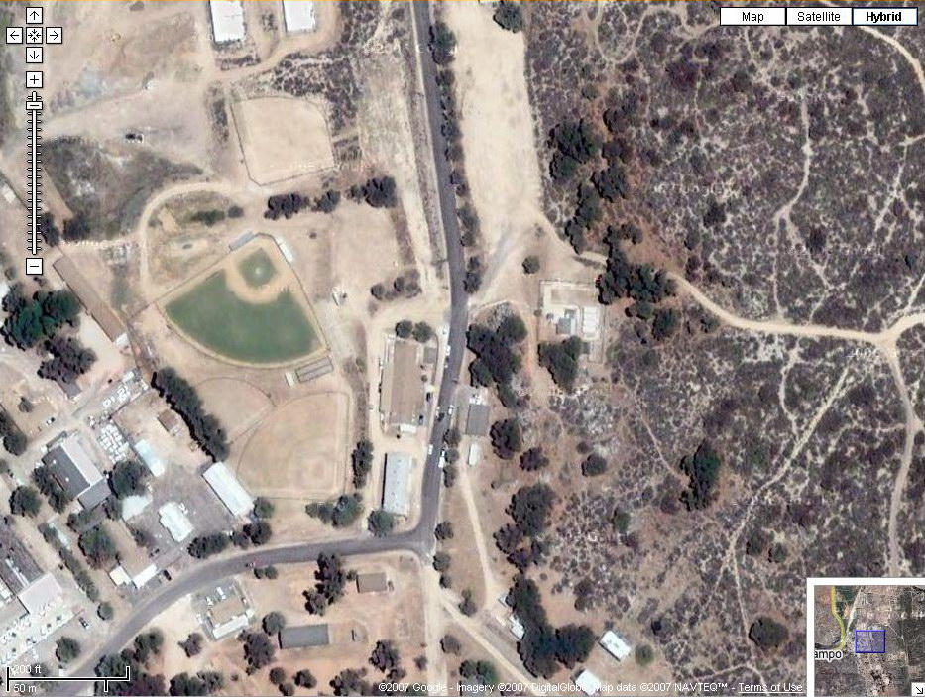
The TOPO map on the left represents the land in the Google aerial photo on the right. Notice the buildings and roads on the map can be seen in the photo.
A navigation map is actually more useful than a photograph since it can highlight important items and ignore clutter like trees and shadows.

Shaded Relief Maps
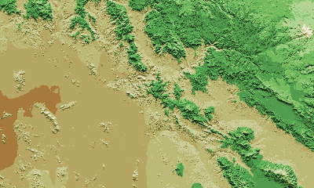
Adding shading to denote shadows thrown by the sun and colors to denote elevation change, beautiful and somewhat realistic maps can be created. The example above shows a high mountain in white in the NorthEast (upper-right) with elevation dropping to a low, flat plain in the SouthWest (lower-left). Mountains, ridges, cliffs, canyons, and plateaus can all be identified. Shaded relief adds depth and interest to a map, but more is needed to make a map truly useful for navigating wild areas.

Contour Lines

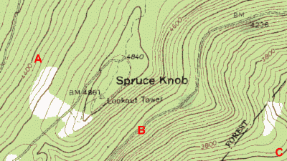

Contour lines are extremely important for outdoors dudes so you know what to expect a mile ahead on the trail. Contour lines show the elevation changes of the terrain. These are called Topographic Maps because they show the topography of the land.
In this example, the elevation at the spot marked A is about 4400 feet above sea level as indicated on the contour line close to it.
The elevation of B is a bit more difficult to figure out, but if you look closely, you might figure out that it is about 4350 feet.
A Topographic Map includes contour lines drawn to represent changes in elevation. When you follow a path on a topographic map that crosses these contour lines, you will be either climbing or descending. A path running parallel to contour lines is relatively flat.
When reading a topographic map, you need to visualize in your mind's eye a 3-dimensional view of what the symbols and contour lines are representing.
The most important thing to remember is that CLOSE contour lines mean STEEP terrain and OPEN contour lines mean FLAT terrain.
Shaded relief added to a topographic map makes it more realistic and helps visualize the real landscape.
For example, see how the mountains and canyons stand out on this map:
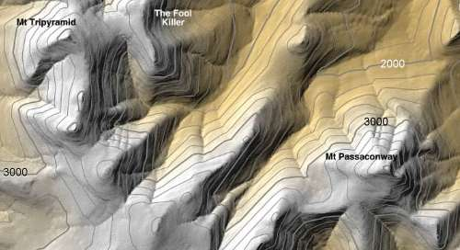

What is the elevation of Mt. Passaconway? _______________
What is the elevation of Mt. Tripyramid? _______________
The closest Index contour line for both peaks is 3,000 feet. You can see another Index line of 2,000 feet. There are 4 Intermediate lines between 2000 and 3000 so each intermediate line represents a 200 foot change in elevation.
Counting up from 3,000 feet, there is 3200, 3400, 3600, 3800, and the top line is 4000 (actually the next index line).
So, both peaks are over 4000 feet and it looks like Mt. Tripyramid is possibly almost 4200 feet high.
This example of a very simple topographic map shows many common features. Keep your eyes open to see these features on other maps and you will start to understand how a TOPO map works.
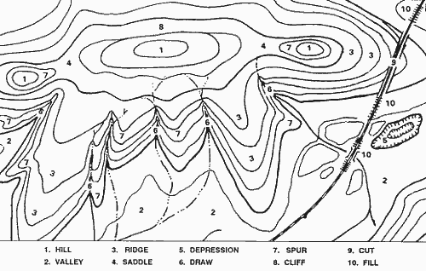
Even without elevation numbers, clues that #1 is a hill include streams converging away from the hilltop, contour lines pointing sharply towards the hilltop (indicating draws), contour lines pointing widely away from the hilltop (indicating rounded ridges).
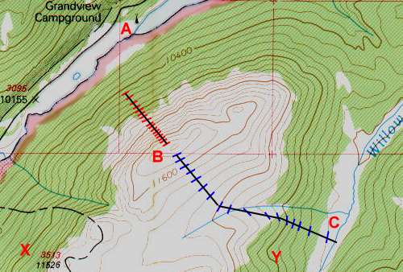
Using contour lines, you can tell a lot about the terrain, including steepness, ruggedness, and ground cover. On the image above, look at point A. There are no contour lines around this location so it is relatively flat here and a good place for a campground by the lake. You can tell from the elevation listed at marker 3095 that the campground is at 10155 feet.
You can also tell the elevation change between each contour line by looking at the Index lines. Notice that the Index line near point B is labeled 11600 feet and the one due north of it is labeled 10400 feet - that is a difference of 1200 feet. Between these two Index lines are two more Index lines so each index line represents a change in 400 feet of elevation - 10400, 10800, 11200, and 11600.
Count the lines between two index lines and you should see there are 4 lines which cause the 400 feet between the two index lines to be divided into 5 intervals, each one being 80 feet in elevation. So, now we know that on this map every contour line represents 80 feet of elevation change.
If you follow a single contour line, your elevation remains constant. For example, starting at point X and following the Index line to the NorthEast, around, and down South to point Y, you would stay at about 10,800 feet.
When you cross contour lines, you are either hiking up or down. Look at the two routes to get to the peak at point B - the red route and the blue route. Each path reaches the top, but the blue route is three times as long as the red route. That means it covers more distance to gain the same elevation so it is a more gradual slope - and probably an easier hike. Going up the red route may require a lot of scrambling and hard work.
Using the map above, pretend you are camped at the Grandview Campground but you heard there is great fishing in Willow Creek at point C over the mountain to the SouthEast. How could you get there?
Well, a straight line to the SouthEast would be shortest on the map, but would include a climb of over 1500 feet!
Instead, heading East from camp and circling the north side of the mountain will result in a longer distance covered but only about 325 feet in elevation! That may be a much better hike.
One other thing to take into consideration. Notice that the ground is colored green up to about the 10,800 foot index line. The white area above that is open ground while the green area is forested. This can be good or bad. The forest can offer shade and coolness, but on the other hand it may be thick and difficult to navigate.
How to Read TOPO Map
From the website: http://www.ghosttowns.com/topotmaps.html
Knowing how to read a USGS topographical map is essential to successfully finding a ghost town. USGS topographical maps are useful because they show the terrain and lay of the land as well as feature like roads, structures and mines. As you read this, it would be helpful if you also had your own topographical map to refer to.
The first thing to notice on a topographical map is the title. It is found in the top right hand corner of the map:
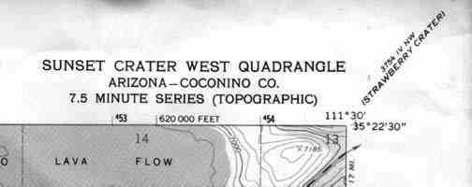
The next thing that you should notice on a topographical map are the numbers running all around the outside of the map. These numbers represent two grid systems that can be used to find your exact location. The first is called latitude and longitude. The exact latitude and longitude is given at each corner of that map and at equally spaced intervals between the corners. The second is called UTM's. These are the smaller bold numbers that run along the border of the map.
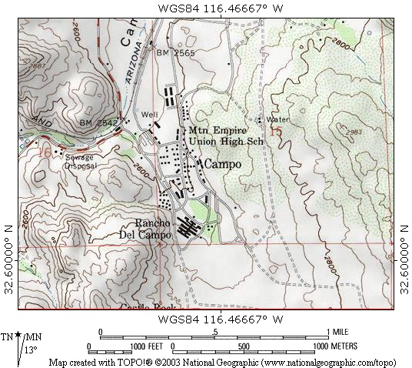
Latitude & Longitude
Latitude and longitude is the most common grid system used for navigation. It will allow you to pinpoint your location with a high degree of accuracy. Latitude is angular distance measured north and south of the Equator. The Equator is 0 degrees. As you go north of the equator the, latitude increases all the way up to 90 degrees at the north pole. If you go south of the equator, the latitude increases all the way up to 90 degrees at the south pole. In the northern hemisphere the latitude is always given in degrees north and in the southern hemisphere it is given in degrees south.
Longitude works the same way. It is angular distance measured east and west of the Prime Meridian. The prime meridian is 0 degrees longitude. As you go east from the prime meridian, the longitude increases to 180 degrees. As you go west from the prime meridian longitude increases to 180 degrees. The 180 degree meridian is also known as the international date line. In the eastern hemisphere the longitude is given in degrees east and in the western hemisphere it is given in degrees west.
Contour Lines
One of the advantages to using a topographical map is that it shows the three dimensional lay of the land. It does this by using contour lines. A contour line is a line that connects points of equal elevation. On the TOPO map they appear as the brown lines. (See map above.) The contour line traces the outline of the terrain at evenly spaced elevations. These are determined by the contour interval. The contour interval is found below the map scale. For this map, the contour interval is 20 feet. That means that every time you go up to another brown line the elevation increases by 20 feet and every time you go down a brown line the elevation decreases by 20 feet. In the lower left hand corner of the map there is a mountain. Notice how the contour lines define the shape of the mountain. The lines are closer together at the top of the mountain where it is steeper. The spacing between the lines decreases as the slope of the mountain decreases.
At the lower left hand corner of topographical maps there is a symbol called the magnetic declination. The symbol is used in conjunction with a compass for navigational purposes. The center line with the star above represents the direction of true geographic north. The line coming of to the right represents the direction of magnetic north, When using a compass, the needle always points to magnetic north. The symbol tells you that for the area the map covers, the magnetic compass needle will always point 13.0 degrees to the east of true geographic north.
Township & Range
The Township and Range system, sometimes called the Public Lands Survey System, was developed to help parcel out western lands as the country expanded. The system takes many western states and divides them up using a base line and a principal meridian:
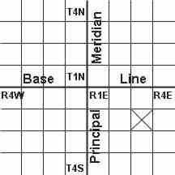
As you go to the east or west of the principal meridian, the range increases in that direction. If you go north or south of the base line, the township increases. This system divides the land up into townships and ranges that are 36 square miles each. In the diagram above, the square with the X in it would be defined as township 2 south (T.2S), range 3 east (R.3E). Each township and range is then subdivided into 36 sections. Each section is one mile square. Individual sections are then subdivided into half sections and quarter sections and so on. On a TOPO map, you will notice a grid with red lines and text crisscrossing the map. The lines represent the boarders of the various sections in the township and range of that area. In the map below you can see sections 23, 24, 26 and 25 of T.22N, R.7E.

The Compass From: http://www.compassdude.com/compass-description.shtml

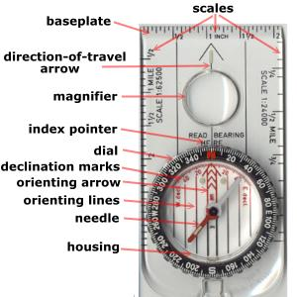

Not all compasses include each of these parts and some compasses include even more.
Base plate | hard, flat surface on which the rest of the compass is mounted. It has a rulers on its edges for measuring distances on maps. It's edge is straight and useful for laying lines on a map
Scales | each edge of a compass may have different rulers for use with different map scales
Direction-of-Travel Arrow | marked on the base plate. You point this the way you will be traveling
Magnifier | for seeing small map features better
Index Pointer | butt end of the direction-of-travel arrow. It ends right at the edge of the dial and is where you take degree readings
Dial | ring around the housing that has degree markings engraved. You hold the dial and rotate it to rotate the entire housing
Declination Marks | use to orient the compass in an area with known declination
Orienting Arrow | marked on the floor of the housing. It rotates with the housing when the dial is turned. You use it to orient a compass to a map
Orienting Lines | series of parallel lines marked on the floor of the housing and on the base plate
Needle | magnetized piece of metal that has one end painted red to indicate North. It sits on a fine point that is nearly frictionless so it rotates freely when the compass is held fairly level and steady
Housing | main part of the compass. It is a round plastic container filled with liquid and has the compass needle inside
Bubble | a bubble of air in the housing liquid is useful for making sure you are holding the compass fairly level
Mirror | lets you see the compass face and distant objects at the same time. Useful for emergency signaling
Sight | improves aiming your compass at distant objects

How a Compass Works
There is a huge magnetic field around the earth. It is huge, but it is not very strong. The magnetized needle in a compass is aligned with this magnetic field. As the image below shows, the composition of the earth acts as a huge bar magnet sitting upside down in the middle of the planet. Since its South end is at the north pole and its North end is at the south pole, the North end of a compass needle is pulled north.
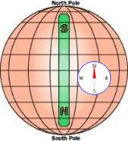
Your compass has to have a very light needle sitting on a pivot that has almost no friction. This is because the earth's magnetic field is weak and would not be able to turn the needle.

General Directions
A compass can be used in many ways, from telling which way is North to finding hidden treasure or following an unmarked path over wilderness terrain. But, you've got to take baby steps, so let's talk about how the a compass is laid out.
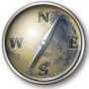
There are four cardinal points on a compass - North, South, East, and West. When reading a compass, and telling other people directions, you need to wipe "right" and "left" out of your vocabulary. Right and Left are relative directions and differ depending on your location and direction, but the cardinal points are constant.
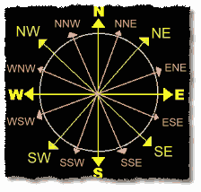
The direction halfway between North and East is an intercardinal point and is called NorthEast. The other three intercardinal points are SouthEast, SouthWest, and NorthWest.
Finally, there are secondary intercardinal points halfway between each cardinal point and intercardinal point. These are North-NorthEast, East-NorthEast, East-SouthEast, South-SouthEast, ... and so on. With these directions, you can give someone a fairly good idea of what direction they need to go. We could add additional points, continuing to break each section in half over and over, but telling someone to go East-EastEastNorthEast-EastNorthEast would not be fun.
Since there IS a need for more precise directions, the circle of a compass face is split into 360 marks called degrees. For rough directions, go ahead and use North or NorthWest. But, for finding your way or locating destinations in the wild, use degrees as you'll see in a bit.

Two Types of Compasses
We will be discussing the mountaineering compass, also called the orienteering compass. This is the type that has a needle that always points north and you need to move a dial to find directions.
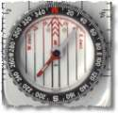
You've seen compasses in cars or toy compasses - neither of these have a noticeable needle and are called "Card Compasses". Actually, there is a magnetic piece like a needle, but it has a paper disk (card) glued to it or has a plastic ball around it that is free to rotate. As the vehicle turns, the card (or ball) remains fixed so the part you see changes. These are fine for general directions, but not helpful for what we want to do.
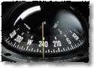

Basic Compass Reading
No matter the compass, one end of the needle always points North. On our mountaineering compasses, it is almost always the RED end, but its a good idea to test your compass before starting to use it.
If you are north of the equator, stand facing the sun around lunchtime. Whichever end of the needle points towards the sun is South and the end that points at you is North.
If you're 'down under' the North end points towards the sun and the South end points at you.
To read your compass,
- Hold your compass steadily in your hand so the base plate is level and the direction-of-travel arrow is pointing straight away from you.
- Hold it about halfway between your face and waist in a comfortable arm position with your elbow bent and compass held close to your stomach.
- Look down at the compass and see where the needle points.
This compass is pointing due North (also 0 degrees)
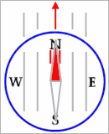
- Turn your body while keeping the compass right in front of you.
- Notice that as the compass rotates, the needle stays pointing the same direction.
- Keep turning until the needle points East like the picture below, keeping the direction-of-travel arrow and North mark facing straight in front of you.
This compass is pointing East (90 degrees)
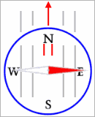
- Important: This is a very common mistake! The compass needle is pointing towards East so I must be pointing East, right? No, no, no!
To find my direction, I must turn the compass dial until the North mark and the "Orienting Arrow" are lined up with the North end of the needle. Then I can read the heading that is at the Index Pointer spot (the butt of the direction-of-travel arrow).
Since the Orienting Arrow is usually two parallel lines on the floor of the compass housing, a good thing to memorize is:
RED IN THE SHED
Now we know we are really heading West (270 degrees)
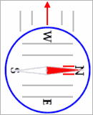

Take a Bearing
By simply moving your compass with your body and using the N-E-S-W markings, you can get a good idea which way you are going. This is often all you need from your compass. But, you've probably noticed on your compass, there are also numbers and tiny lines. These represent the 360 degrees in a circle that surrounds you no matter where you are.
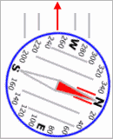
When you need to find your way from one particular place to another, you need to use these numbers to find out the bearing to that remote place. The direction you are going is called your heading. Heading and Bearing are pretty much the same thing. The image above is a heading of about 250 degrees.
Using your compass, take a few bearings. Move your body until the direction-of-travel arrow points at the following items and then turn the dial until "RED is in the Shed". Then, read the bearing at the Index Pointer:
- You computer screen: ____________ degrees
- Your window: ____________ degrees
- Your door: ____________ degrees
- A light switch: ____________ degrees

Compass Reading Tips

- Hold the compass level - if the compass is tilted, the needle will touch the clear lid and not move correctly.
- Read the correct end of the needle.
- Use common sense, such as knowing that if you are heading anywhere towards the sun, there's no way you can be heading north, northwest, or northeast.
- RED IN THE SHED!
- Keep the compass away from metal objects - even a knife, flashlight, or keychain can cause a false reading if too close to the compass.

Main Compass Uses
The main functions of using a compass are:
- tell which direction you are traveling - your heading
- tell which direction an object is from you - its bearing
- keep you following a straight line of travel
- orient a map - aligning a map with the actual land
- triangulation - determining your location with a map
- plan routes - determine directions and distances to travel on a map
We've already discussed an important skill in how to use a compass and that is determining your heading. Point the direction-of-travel arrow straight ahead in the direction you are going, turn the compass dial until RED is in the Shed, and read the heading at the Index Pointer.
Determining the bearing to an object is just like finding your heading. Turn to face the object and do the steps for determining your heading. Here's a simple exercise to try...
On a hike in Wyoming, you see a strange rock formation off in the distance. Using your compass, you take a bearing to it as shown below:
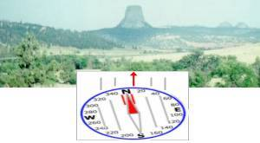
If you turn and face two smaller rock formations further off in the distance, which of the following bearings would be correct?
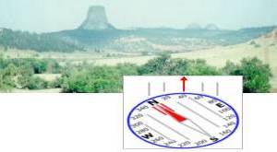
1
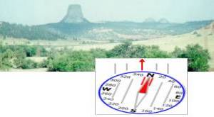
2
In this case, since you are facing northerly, a turn to the right will be more to the East so #1 is correct. It is important to keep a feel for general directions in your mind. If the sun is at your back, you are heading northerly. If its early morning and the sun is in your face, you are heading east with north on your left and south on your right. Remember, right and left are relative to your current heading.
Learning how to use a compass to follow a line of travel is simply pausing to take a reading occasionally while hiking. In the picture below, you're trying to find your way to the lake in the distance to refill your water supply.
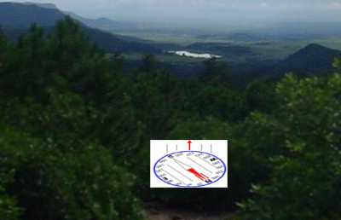
In this opening in the forest, you pause to take a bearing to the lake and see that it is about 220 degrees.
Ahead of you, there is no trail and you drop into thick forest. You won't be able to see the lake or easy landmarks for quite awhile.
As you walk, you need to occasionally check your heading on the compass to ensure you are still heading 220 degrees.

Web Resources
E-book, Reading TOPO Maps. http://www.map-reading.com/intro.php
How to read TOPO Maps: http://www.ghosttowns.com/topotmaps.html
Compass and Map Skills: http://www.compassdude.com/default.shtml

