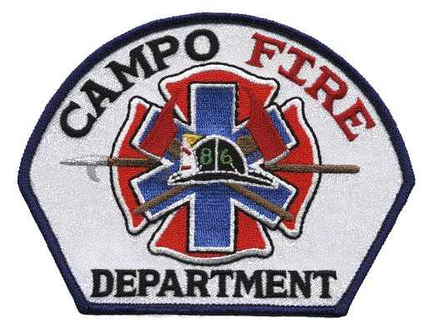Campo Fire and Rescue, Mountain Empire CERT Team
437 Jeb Stuart Road Campo, CA 91906
Station Phone: 619-478-5310
Postal address
PO Box 55 Campo, California 91906
e-mail: campofire@yahoo.com

Community Emergency Response Team (CERT)
If available, emergency services personnel are the best trained and equipped to handle emergencies, and you should use them. However, following a catastrophic disaster, you and the community may be on your own for a period of time because of the size of the area affected, lost communications, and impassable roads.

CERT training is designed to prepare you to help yourself, your family, and your neighbors in the event of a catastrophic disaster. Because emergency services personnel will not be able to help everyone immediately, you can make a difference by using your training to save lives and protect property.

CERT training covers basic skills that are important to know in a disaster when emergency services are not available. With training and practice and by working as a team, you will be able to do the greatest good for the greatest number of victims after a disaster, while protecting yourself from becoming a victim.

COMMUNITY EMERGENCY RESPONSE TEAM
VOLUNTEER AGREEMENT and CODE OF CONDUCT

I agree and understand that any work I perform on behalf of the Mountain Empire Community Emergency Response Team (ME CERT) will be provided on a voluntary basis, and that I do not expect payment or other compensation for performing such work. I further understand and agree that a volunteer position does not constitute an employee-employer relationship with Campo Fire and Rescue Department, and that the Department may terminate my volunteer status at any time. The Campo Fire and Rescue Department is under no obligation to reimburse me for training or duty related expenses.
I acknowledge and accept the obligation to serve the public while maintaining the highest ethical standards in both personal and official conduct.
I have read, understand, and will comply with the Campo Fire and Rescue policies regarding the following areas:

Confidential Information: | You may be exposed to sensitive information during your assignment as a volunteer. Remember, official business of the Department is confidential. Members shall discuss or give official information only to persons for whom the information is intended, as directed by supervisors or as required by law.
Injuries: | If you are injured while performing volunteer duties, you should immediately, or as soon as safety permits, report your injury to the Campo Fire Department CERT Program Coordinator.
ME CERT Code of Conduct: | All CERT members must sign and adhere to the Campo Fire / ME CERT Code of Conduct. Failure to follow the ME CERT Code of Conduct will result in your removal from the team

CODE OF CONDUCT

- Membership on the Mountain Empire Community Emergency Response Team does not authorize or encourage self-dispatching to assist first responders on non-disaster missions. ME CERT members will be deployed and assigned by Campo Fire & Rescue in all cases except for disasters of massive public impact.
- CERT members will only undertake activities that are within their physical capabilities and scope of training, and will not take risks that are likely to cause injury to themselves or others. DO NOT BECOME ANOTHER VICTIM.
- Use of any alcoholic beverages or non-prescription drugs is prohibited by any member involved in ME CERT activities, including meetings, training classes, or special events.
- Use of, or carrying of, any firearms or other weapons is prohibited by any member involved in ME CERT activities, including meetings, training classes, or special events.
- Equipment and emergency gear issued to ME CERT members must be maintained in good condition, and must be stored in a place that will prevent items from being borrowed or taken by unauthorized persons.
- Equipment and emergency gear issued to ME CERT members must be signed for and returned if the volunteer wishes to become inactive or whose service is terminated.
- All ME CERT members are required to attend four (4) meetings or training sessions per calendar year. Failure to complete this attendance will result in the member being placed on the inactive list and his/her equipment will be returned.
- CERT I.D. cards, vests and hard hats will only be worn during official ME CERT activities.
- ME CERT members will not use their membership in this program or their identification cards to gain favors, preferential treatment, or to influence others for any purpose other than emergency preparedness.
- ME CERT members will not operate any vehicles or machinery not owned by them, unless assigned to do so by professional first responders.

I (PRINT NAME) _____________________________ do hereby certify that I have read and understood and agree to abide by all of the above rules and have also read and understand the current ME CERT Standard Operating Procedures document. I understand that failure on my part to comply with any of these rules or procedures could result in the termination of my volunteer service on the Mountain Empire Community Emergency Response Team. I further understand that if I am removed from service, it is my responsibility to return all issued identification cards, equipment and materials that I have received from the ME CERT program. If I fail or refuse to return the equipment or materials, I agree to pay the initial cost of any items not returned.

________________________ ___________________________ _______________
Member Signature Campo Fire, CERT Program Manager Date

________________________
Chief Mitch Sanchez

